RELEASE: 1st October 2023
Bohomoon Presents the Christmas Treats: Advent Calendar and Christmas Crackers Filled with Exclusive Products and Irresistible Savings
Bohomoon, the leading online jewellery retailer, is excited to introduce their first-ever Advent Calendar and Christmas Crackers. These festive treasures offer customers the perfect way to count down to Christmas while enjoying exclusive products and unbeatable savings.
Bohomoon's Advent Calendar comes with 24 drawers, each concealing a stunning piece of jewellery. Valued at over £360, this incredible calendar is priced at just £180. Customers will be delighted to discover 24 surprises, 2 that are calendar exclusives, as they indulge in a daily dose of joy leading up to Christmas.
For those seeking a more compact option that doesn't skimp on luxury, Bohomoon's 12-door Advent Calendar is the perfect choice. Valued at over £210, this calendar is available for just £100. Customers can still enjoy the thrill of discovering new jewellery while saving on their Christmas shopping.
Additionally, Bohomoon's Christmas Crackers provide a mystery mix of three items worth over £65, all for the exceptional price of £20. These delightful crackers are the perfect addition to any holiday gathering, bringing extra sparkle and surprise to the festivities
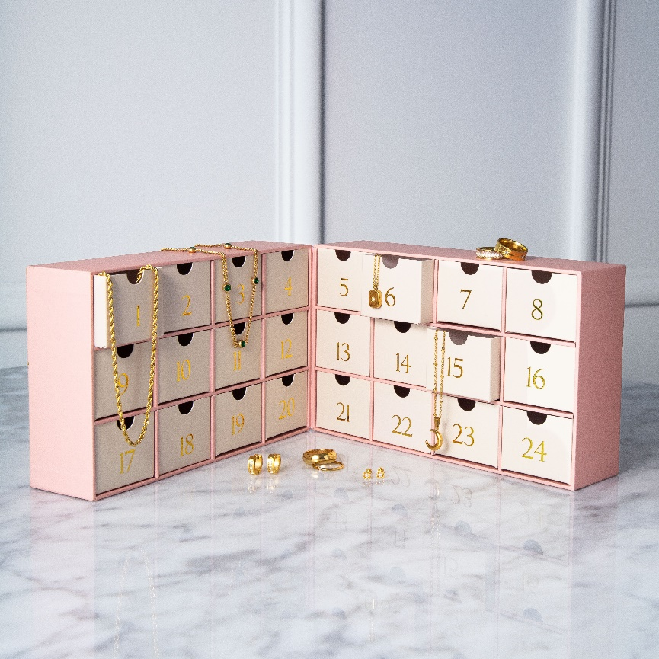
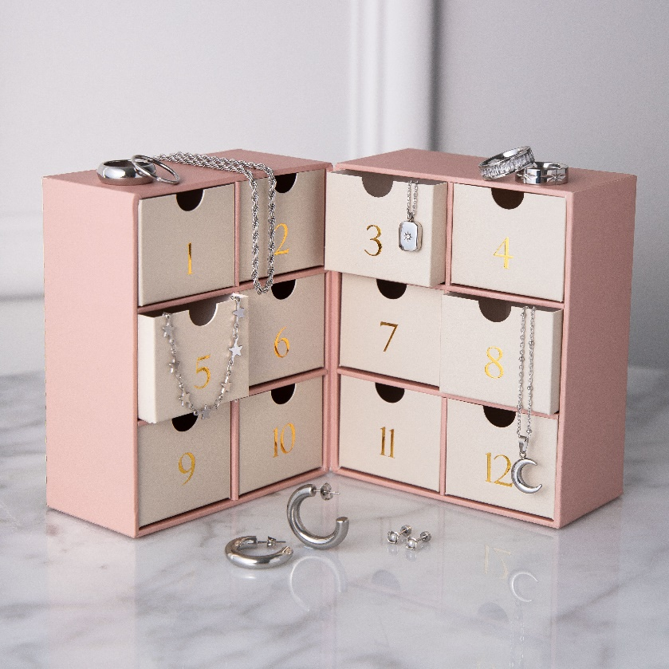
Both the Advent Calendar and Christmas Crackers collections have limited stock! Customers are encouraged to pre-order theirs before the sell out!

About Bohomoon:
Bohomoon is a leading online jewellery retailer, with over 1000 pieces, you'll be spoilt for choice. Stunning pieces made from stainless steel in gold, silver, and rose gold. Best of all, our jewellery is crafted to be tarnish-free and waterproof, so you can enjoy your favourite pieces without worries. With a commitment to providing customers with high-quality jewellery at unbeatable prices.
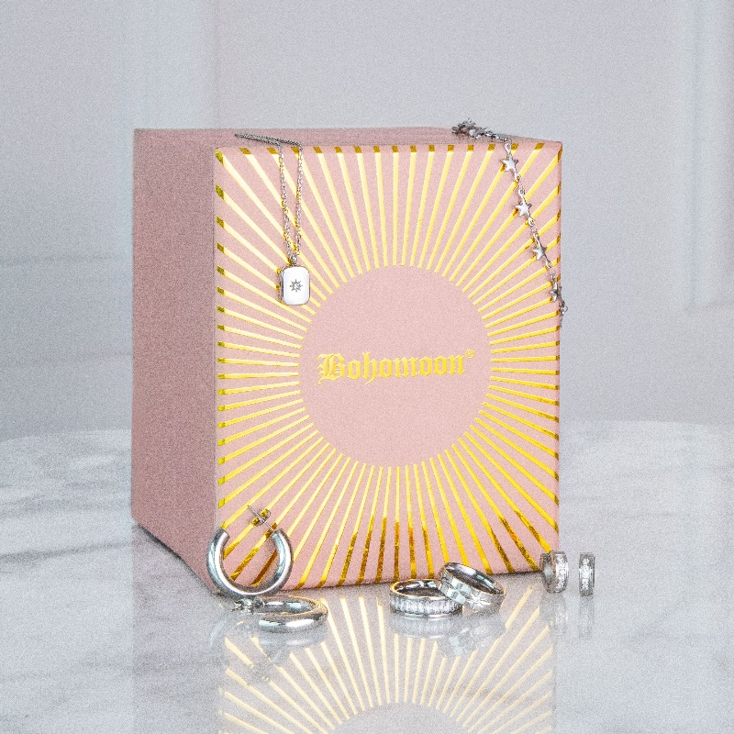
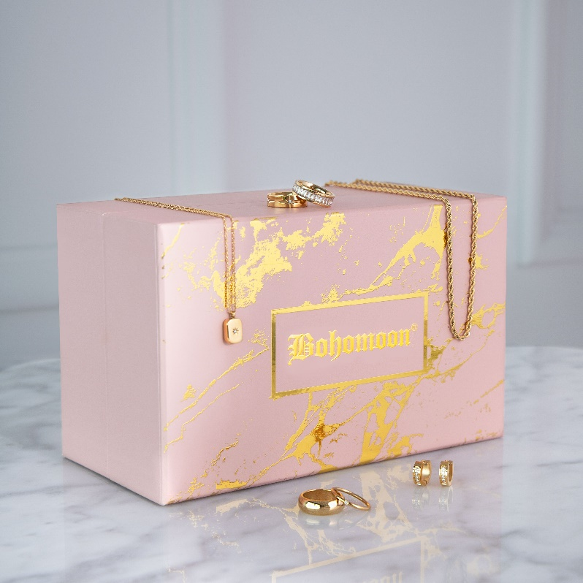
For media inquiries, please contact:
Stephanie Bergin
Head of Marketing
stephanie@bohomoon.com or heather@bohomoon.com

