I’m Dreaming Of A Love Cocoa Christmas…
Love Cocoa Unwraps New Look & Festive Collection

Frosty mornings, an open fire, mulled wine… and chocolate. We all know Christmas is really about the chocolate. If you’re looking for something a little bit different, why not take a closer look at luxury, sustainable chocolate brand, Love Cocoa? Its new Festive Collection is indulgent, sophisticated and irresistibly delicious – and it all comes merrily packaged, as well as being 100% plastic free.
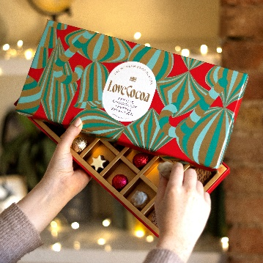
That’s not all, Love Cocoa has just had a makeover, with a new luxe look that shines a spotlight on its sustainable, ethical credentials. The brand’s commitment to responsibly producing delicious, high-quality chocolate remains, and the new designs are reflective of the luxury chocolate that lies within. The B Corp certified brand is all about driving positive change within the chocolate industry, led by modern chocolatier and founder, James Cadbury. Crafting with pride and care, Love Cocoa uses only the finest quality cacao that’s ethically sourced from growers who farm fairly and pay their workers properly.
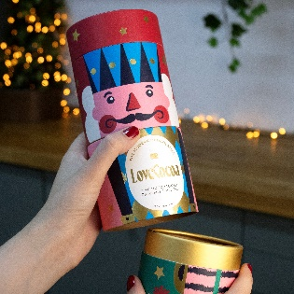
As part of its ecological commitments, Love Cocoa works with Eden Reforestation Projects via 1% for the Planet, with the aim of planting over 200,000 trees each and every year. To date, the brand has planted 1.6 million trees across North and East Africa in a bid to combat deforestation and climate change.
NEW! The Nutcracker - £20/270g
Buy from Anthropologie, Fenwick, John Lewis, Liberty, Next, Selfridges – and https://lovecocoa.com/products/christmas-chocolate-nutcracker
A stylish novelty gift, this festive chocolate treat trio has three twisting layers, each filled with delicious chocolate delicacies, including: Salted Caramel Cocoa Almonds, Colombian Milk Chocolate Buttons and Salted Caramel Chocolate Truffles.
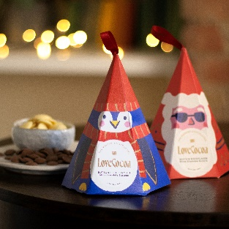
NEW! Santa’s Snowflakes & Buttons the Penguin - £7/100g
Buy from Anthropologie, Fenwick, Liberty – and https://lovecocoa.com/products/buttons-the-penguin-christmas-milk-chocolate-buttons & https://lovecocoa.com/products/santas-snowflakes-christmas-white-chocolate-buttons
The cutest Christmas treats around! Choose from Santa’s Snowflakes, made from deliciously smooth and silky white chocolate or Buttons the Penguin, made from creamy milk chocolate buttons.
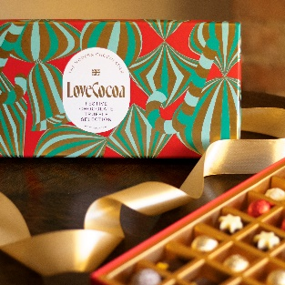
NEW! Christmas Chocolate Truffle Selection - £25/220g
Buy from Anthropologie, Fenwick, Liberty, Next, Thortful and https://lovecocoa.com/products/festive-chocolate-truffle-selection-box
A selection of luxury, handmade chocolate truffles, featuring delicious festive flavours. Perfect for gifting and sharing, these truffles are guaranteed to help spread some festive cheer.

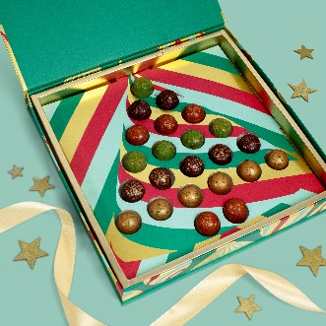
NEW! Chocolate Bauble Truffle Collection - £40/300g
Buy from Next and https://lovecocoa.com/products/luxury-chocolate-christmas-tree-truffle-selection-box
A selection of luxury chocolate ‘bauble’ truffles inside a fabulously festive Christmas tree box, with four carefully curated (and colourful) flavours, each as rich and delicious as the next. This box is the perfect festive gift, post-dinner treat and sweet snack to take you through the holiday season.

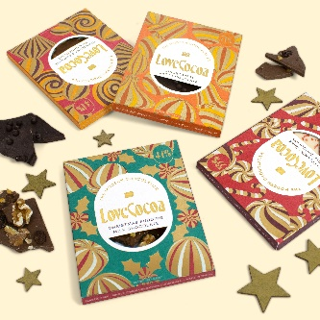
NEW! Festive Bars - £5/75g bar
Buy from lovecocoa.com and Anthropologie, Fenwick from September.
A quartet of merry bars. Welcoming new Cranberry & Caramel Milk Chocolate Bar… creamy Colombian milk chocolate and smooth caramel, sweet dried cranberries, with a swirl of white chocolate. And why not try one of Love Cocoa’s signature limited edition bars, which have all been given a swish new look: Christmas Pudding Milk Chocolate Bar, Gingerbread Dark Chocolate Bar and Peppermint White Chocolate Bar.
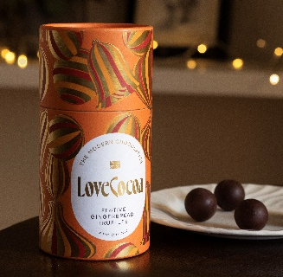
Festive Gingerbread Truffles - £15/150g
Buy from Anthropologie, Liberty, Next and https://lovecocoa.com/products/gingerbread-chocolate-truffles
Filled with a spiced gingerbread ganache and coated in rich, smooth Ecuadorian dark chocolate, these truffles are a delicious festive treat, and have been given a new luxe look for Christmas 2023.

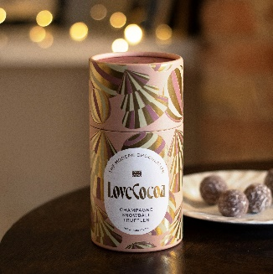
Champagne Snowball Truffles - £15/150g
Buy from Anthropologie, Liberty, Next, Thortful and https://lovecocoa.com/products/champagne-snowball-chocolate-truffles
Filled with a creamy milk chocolate ganache, made with fresh cream infused with Marc de Champagne, and sealed in a chocolate shell delicately topped with icing sugar for a wintery finish. These truffles have been given a new luxe look for Christmas 2023.
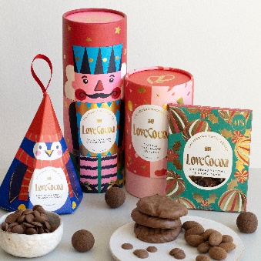
Festive Fun Gift Box - £42
Buy from lovecocoa.com
A delightful hamper filled to the brim with fun festive treats featuring Love Cocoa’s new luxe packaging. Starring a seasonal Christmas Pudding Bar, the stylish Nutcracker, Buttons the Penguin, and the brand’s bestselling (and truly decadent!) Double Chocolate Biscuits.

Festive flavours crafted with care,
this is Christmas chocolate made with love by the Modern Chocolatier.

-ends-

Contact Rachel Lawrence PR for further information / images:
rachellawrencepr@gmail.com
07932 384805

About Love Cocoa
In 2016, Cadbury descendant, James Cadbury, founded Love Cocoa upon the same ethical values that were at the heart of the original Cadbury company, and with sustainability at the core of its mission. Since then, the luxury brand has become known for its contemporary take on classic flavours that are aligned with modern, sustainable standards. Avoiding plastic and palm oil, planting trees to support reforestation projects and ethically sourcing their cocoa, the brand is all about driving positive change within the chocolate industry.
As well as tablet bars, Love Cocoa’s range now includes truffles, selection boxes, hot chocolate flakes, biscuits and seasonal gifting. The B Corp certified business is a proud member of 1% for the Planet, working in partnership with Eden Reforestation Projects to combat deforestation and climate change. To date, the brand has planted 1.6 million trees in North and East Africa. Love Cocoa is stocked in Anthropologie, Harrods, Fenwick, John Lewis, Liberty and Selfridges, plus independent outlets nationwide, and via lovecocoa.com.

