XOOTZ LAUNCHES NEW
SKETCH YA DECK SKATEBOARDS
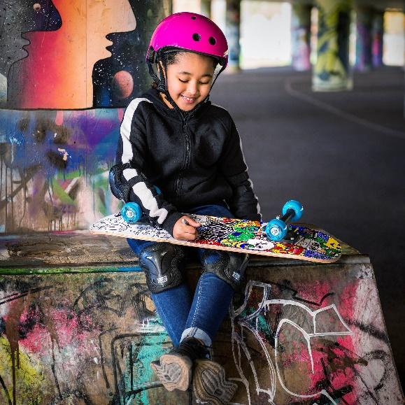

April 2022:
Let your kids create their own kickflipping style with the new Sketch-Ya-Deck (RRP £32.99) from Xootz – the colour-in, complete beginner's skateboard.

A shorter 28" flat deck made of durable 9-ply maple provides a sturdy platform for beginners to learn on and master the basics of skating. Completed with stylish lightweight 5" black plastic trucks, this customisable skateboard features a fun colour-in design on the bottom and four permanent markers so that your little ones can get creative and make their board utterly unique to them.

As with all Xootz skateboards, the Sketch-Ya-Deck comes fully assembled so you won't have to worry about putting it together. Simply sketch and go!

For further information, imagery, and sample requests, please contact Playtime PR:
Louise Hathaway: louise@playtimepr.com / 07970 770572
Sophia Hutchinson: sophia@playtimepr.com / (0)7713 969952

- ENDS -
About Xootz:
Xootz. Fun Without Limits.
Xootz bridges the gap between wheeled toys and action sports and our mission is to inspire and encourage kids to get outdoors and have fun without boundaries and to do it in style!The Sketch-Ya-Deck is the latest model to join the Xootz collection of skateboards designed for all ages and abilities including the Mini 17” Skateboard, 22” Complete Cruiser, and Deviate Double Kick Skateboard.

The Xootz Sketch-Ya-Deck is available from stockists including Amazon, Argos, Very, Littlewoods, and Halfords.

Since 2014, Xootz has developed a multi-award-winning range of scooters, go-karts, skateboards, electric drift trikes, skates, and ride-ons including premium officially licensed vehicles from BMW to McLaren. This offers hours of thrills for kids with no boundaries.
Xootz products are available from a range of well-known stockists, including Amazon, Argos, Very, Littlewoods, Skates.co.uk, Halfords, and Skate Hut.
Follow Xootz on social media:
Instagram: @xootzofficial
Facebook: @xootzofficial

