Splats Head

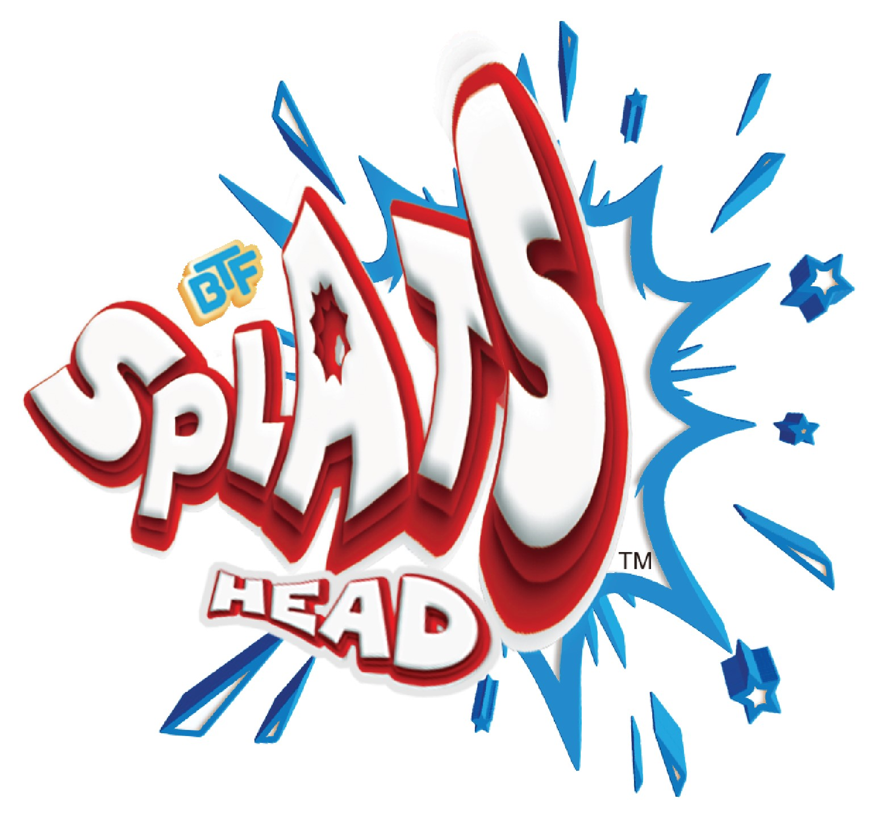

KAP Toys presents our new craze hit Splats Head!
The fun and crazy shape shifting, face distorting craze. Let your Splats fall on the table or on the floor… its weight will transform it into a new crazy, funny shape! Challenge your friends to see who can create the most amusing shapes.
Available in 12 humorous characters, choose from Piecy, Skilfy, Bracy, Bamboo, Dotsy, Pudgy, Dulli, Sheddy, Smoon, Laful, Angri or Pompo. Squish and splat them for endless funny creations. Get ready for Splats!
Challenge your friends to see who can create the funniest shapes! Squish and splat them for endless funny creations.

For more info please see our KAP Toys website:
Splats Head - KAP Toys

