BEANO®
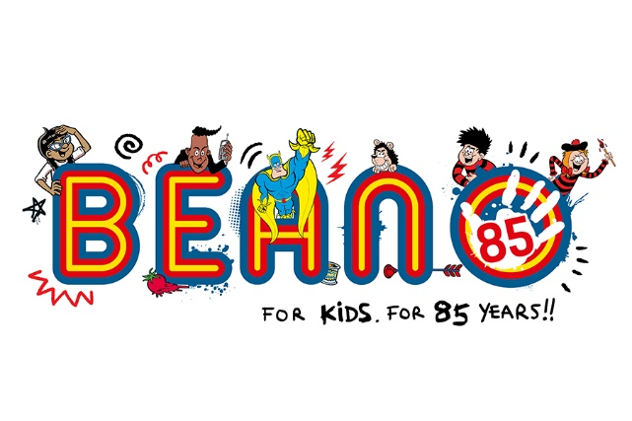
KAP TOYS is thrilled to be working with one of the most recognisable British brands of all time, BEANO®! Launching new exciting product for Christmas 2023 and into 2024, we have 3 lines launching imminently! SQUISHII® Character Plush, Joke Box and a make your own comic book kit, the first of KAP TOYS Comikits™. Launching nationally with Sainsburys in November 2023 and unleashed to the wider market from January 2024. We expect to have a lot more retail partners on board by the time we get to World Book Day on 7th March 2024!!! Watch this space!!!

With bright, eye-catching packaging alongside the famous BEANO® characters, these products will jump off shelf and create an impactful display for all retail formats. With product that ties in perfectly to the brand, these are ideal gifts throughout the year not just for birthdays and Christmas! Who wouldn’t want to ‘unleash their comic genius’ with the ComiKit™ or ‘set their inner prankster free’ with the Box of Tricks! A fantastic everyday offering for the new generations of BEANO® fans!
#bemorebeano
For more info, please see our KAP Toys website:
Beano - KAP Toys

Notes to Editors:
Further information about Beano:
Beano was first published in July 1938 and is still created every week in its original Dundee headquarters and printed in the UK. Voted Children’s Magazine of the Year in 2022 in the PPA Scotland Awards, Beano recently reported an ABC of 54,876 and is in its sixth consecutive year of circulation growth. The brand reaches over 5m fans a month on its digital network, centred around multi-award winning Beano.com, featuring jokes, quizzes, and games in a kid safe environment.

