FIND THE PERFECT VALENTINES GIFT FOR HER WITH REMINGTON

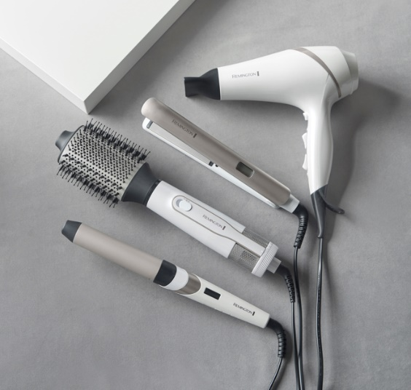
HYDRALUXE RANGE
Pull out all the stops this Valentine’s Day and spoil that special someone in your life with the help of Remington.
The Hydraluxe range features a hairdryer, curling wand, straightener and a volumising air styler, the perfect gifts for your loved one this Valentine’s Day.
The Hydraluxe range is a favourite for fitness entrepreneur and influencer Lucy Mecklenburgh, UK haircare ambassador for Remington, who says:
“When I’m dashing between shoots and events, my hair really feels the strain of heat styling. I learnt to make sure I was looking after my hair and investing in styling tools that care for your hair!
“The Hydraluxe range is perfect for anyone wanting to switch up their style, while also caring for their hair – healthy, shiny hair always makes you feel good.”
With Moisture Lock Technology, this collection protects the hair whilst styling, leaving you with the perfect balance of moisture and gorgeous, glossy results. That’s not all, the products also have built-in Hydraluxe Technologies meaning you can achieve expert-salon results without causing excessive heat damage*!
Hydraluxe Straightener available at Argos, Amazon & Boots for RRP £99.99
Hydraluxe Volumising Air Styler available at Argos, Amazon & Boots for RRP £46.99
Hydraluxe 32mm Wand available at Argos, Amazon & Boots for RRP £36.99
Hydraluxe AC Hairdryer available at Argos, Amazon and Boots for RRP £62.99

COCONUT SMOOTH RANGE
Finding the perfect Valentine’s gift can be hard but look no further, as Remington has you covered.
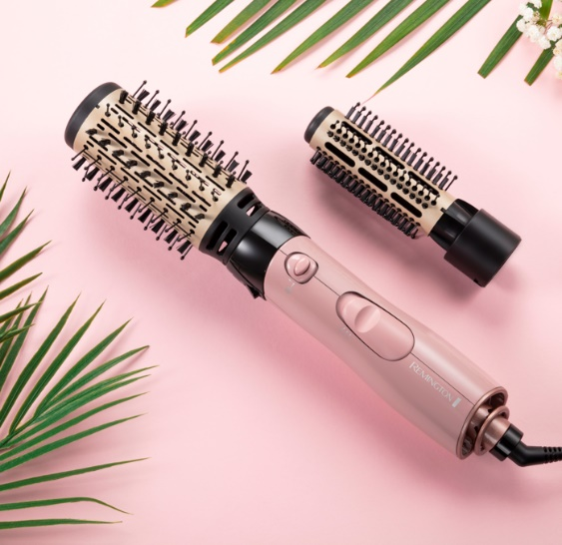
In a beautiful pearly pink colourway, the stunning Coconut Smooth collection of haircare styling tools includes a straightener, hairdryer, and curling wand. However, it doesn’t stop there!
The Coconut Smooth range has recently introduced its very own Hot Air Styler with two attachments: a 30mm round bristle brush and a 50mm round bristle brush.
The coconut infused barrels of the Coconut Smooth Hot Air Styler feature ionic conditioning to help tame any pesky frizz, for a perfectly polished, long-lasting and smooth result.
The Remington Coconut Smooth Hairdryer is available exclusively from Argos and has an RRP of £31.99
The Remington Coconut Smooth Straightener is available exclusively from Argos and has an RRP of £31.99
The Remington Coconut Smooth Curling Wand is available exclusively from Argos and has an RRP of £31.99
The Remington Coconut Smooth Air Styler is available exclusively from Argos and has an RRP of £34.99

PRO BIG CURL TITANIUM CERAMIC TONG
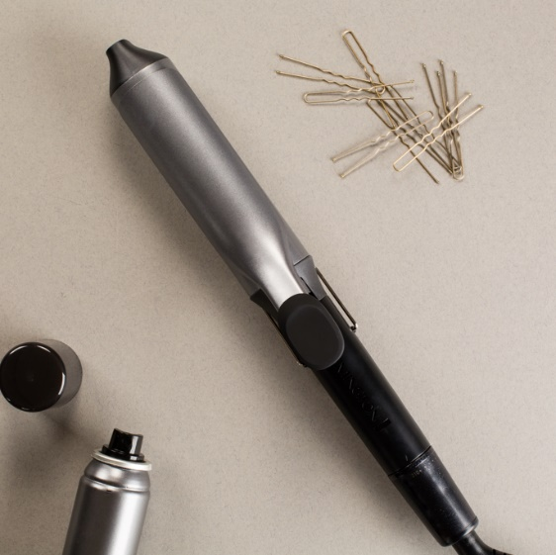
Create big, glossy romantic curls that last with Remington’s Pro Big Curl Tong! If your other half loves to be bold with their style, this gift will make their hearts skip a beat.
The Pro Big Curl is the perfect appliance for achieving big and bouncy curls thanks to the 38mm barrel. With an impressive heat up time of 30 seconds and 8 temperature settings, you can achieve your desired look in time for date night.

The Pro Big Curl/ Jumbo Tong is available from Argos and Amazon for RRP £21.99
*No added damage vs. air-dried, un-styled hair when styling with the Hydracare function switched on at the recommended temperature
**vs standard ceramic coating

ENDS
*No added damage vs. air-dried, un-styled hair when styling with the Hydracare function switched on at the recommended temperature
**vs standard ceramic coating
For further information, high-res product images and samples please contact remington@hatchpr.co.uk or call 0113 361 3600.
About Remington
As a division of Spectrum Brands Holdings powered by innovation, Remington has been helping the world get ready for 80 years. We pride ourselves on being at the very cutting-edge of technology and work with top salon professionals from all over the world to produce electrical personal care products that really work, care for you and deliver superior results every single time. For more information about Remington, please visit www.remington.co.uk.
About Spectrum Brands Holdings, Inc.
Spectrum Brands Holdings (NYSE: SPB), a member of the Russell 1000 Index, is a global and diversified consumer products company and a leading supplier of residential locksets, residential builders' hardware, plumbing, shaving and grooming products, personal care products, small household appliances, specialty pet supplies, lawn and garden and home pest control products and personal insect repellents. Helping to meet the needs of consumers worldwide, our Company offers a broad portfolio of market-leading, well-known and widely trusted brands. In Europe, these brands include Remington,

