Introducing Nairn’s Gluten Free Oats Your Way™
The Deliciously Versatile Way to Enjoy Wholegrain Oats!
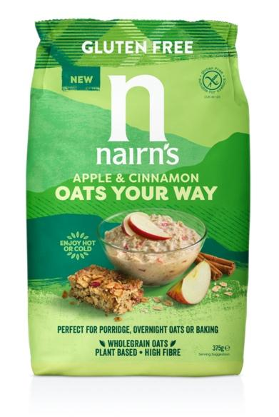
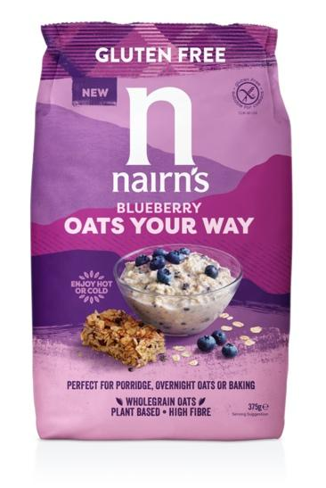

Delicious, simple and convenient, say hello to your new favourite breakfast companion: Nairn’s Gluten Free Oats Your Way™! Made with wholegrain oats and real fruit pieces, these new additions to the growing Nairn’s range are set to transform your morning routine with their versatility.
Choose from apple and cinnamon or blueberry, both bursting with natural flavour. Packed full of wholegrain goodness, these tasty multi-tasking oat cereals can be prepared in a variety of ways - the options are endless and the choice is yours!

- Cook traditionally on the hob, or in the microwave, and enjoy as a quick and easy porridge with a fruity twist
- Soak overnight, with your choice of milk, fruit juice, fresh fruit, nuts and yoghurt to enjoy as overnight oats for breakfast or a nutritious snack
- Add to a smoothie for an instant hit of fruit and fibre
- Don’t stop at breakfast and brunch, you can even bake with them! Oats Your Way™ are perfect for creating flapjacks, cookies or even some flipping-good fruity pancakes!

The flavours:

- Apple & Cinnamon – a classic combination of juicy red apple pieces with a little kick of cinnamon, almost reminiscent of apple pie but without the guilt!
- Blueberry – the distinctive aroma and taste of sweet blueberries in this ever-popular flavour is sure to be a firm family favourite.

Nairn’s have been baking with oats since 1896 and have always been passionate about making products that are simple, natural and wholesome. Oats Your Way™ continues that tradition in a style that is bang on trend and perfect for today’s healthy living customer, delivering all of the goodness of wholegrain oats with no compromise on flavour. High in fibre, with no added sugar, and no artificial colours, flavours or preservatives, this new addition to the range will soon become one of your store cupboard essentials.
Nairn’s Gluten Free Oats Your Way™ at a glance:
- Packed full of gluten free wholegrain oats and real fruit
- Contains no artificial colours, flavours or preservatives
- High in fibre
- No GM ingredients
- Suitable for vegans
- Suitable for Coeliacs (carries the Coeliac UK Crossed Grain logo)
- No hydrogenated fat

Nairn’s Gluten Free Oats Your Way™ (RRP £2.79, 375g) are now available from Ocado and Holland & Barrett, and will be in Morrison’s from 19th April, and Sainsbury’s from the end of May.

END

For further press information, images or samples please contact Annabel Dodd at CCD PR on 020 7434 4100 or email Annabel@ccdpr.com
To view the full range from Nairn’s, please visit: www.nairns-oatcakes.com

Notes to Editors:
Edinburgh based Nairn’s has been baking with oats since 1896. They are the UK’s number one producer of oatcakes, as well as one of the leaders in branded Gluten Free products with an extensive, growing range that now includes oatcakes, crackers, flatbreads, sweet biscuits, cereals and snacks. Staying true to their roots, all Nairn’s products are deliciously simple, natural and wholesome and do not contain any artificial colourings, flavours or preservatives.
There has been a great deal of research into the positive health and lifestyle benefits of oats. Oats are high in fibre and contain complex carbohydrates that give a natural and wholesome boost. Oats have also been shown to have a beneficial impact on the gut which is widely referred to as the “second brain”.

In 2017, Nairn’s opened the doors of its bigger, ‘state of the art’ gluten-free bakery in Newtongrange, Midlothian, in response to growing demand for Nairn’s Gluten Free products. The new bakery has provided the capacity and technology to expand the range with an ongoing pipeline of new products.

