ZIPLINX CAUSES CHAIN REACTION AS LATEST TOY SENSATION FROM JOHN ADAMS
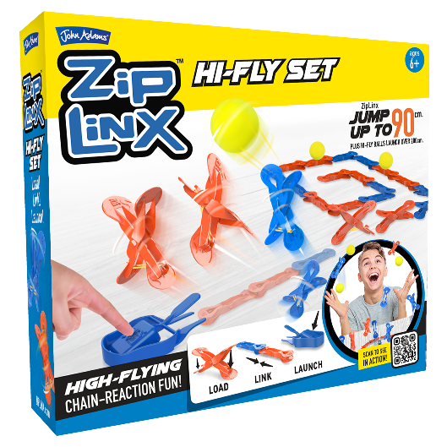
Create high-flying chain-reaction fun with this year's coolest toy sensation - ZipLinx! The latest fun, family domino style challenge, that children and parents can create their own amazing designs ready to launch in minutes, then send them flying into the air with one push of the launcher key.

Perfect for children looking for a pocket money treat, and an easy win for parents searching for the latest viral toy sensation, or just a very cool birthday gift. There's hours of creative fun to be had with this specially designed system of spring-loaded linx that launch in to action.

With no limit to how many ZipLinx can be connected in this clever chain-reaction, you can create your own amazing designs ready to launch in minutes, then send them flying into the air with one push of the launcher key. It is also super easy to set up, with no accidental starts.

Prepare to wow friends and family, as your ZipLinx creations jump up to 90cm's in the air plus, watch the Hi-Fly balls launch to over 200cm – simply load, link and launch!

Record and share for even more fun! Once you have created a design, record your ZipLinx action in slow motion and playback, then share with friends and family to show them your cool creations. Try linking multiple sets together for a super impressive display to film and share - there are hundreds of design layouts to create!

This high-flying toy is ideal for anyone that loves to build and create and with four different sets available, the fun never stops. Available to buy now from Smyths Toys, Amazon and Argos.

Choose from:
- ZipLinx Jump Set - (RRP £14.99) includes 18 Linx, 3 Hi-Fly balls, 1 launcher key, 23 power bands and 1 band placer.
- ZipLinx High-Fly Set - (RRP £19.99) includes 22 Linx, 3 Hi-Fly balls, 1 launcher key, 28 power bands and 1 band placer.
- ZipLinx Power Tower Set - (£24.99) includes 28 Linx, 4 Hi-Fly balls, 1 launcher key, 32 power bands, 1 band placer, 1 Target Launcher, 1 Tower, 1 Tower Base, 1 Tower Trigger.
- ZipLinx Triple Tower Blast Set - (£34.99) Includes 28 Linx, 4 Hi-Fly balls, 1 launcher key, 32 power bands, 1 band placer, 1 Target Launcher, 1 Tower, 1 Tower Base, 1 Tower Trigger.

-Ends-
Notes to editors

ZipLinx is suitable for children aged 7 years and over. For more information, head to www.johnadams.co.uk

Further information, interviews and images are available on request.
Contact Venetia or Sophie at the John Adams press office
(Norton PR): +44 (0)1608 812830 Email: Venetia@nortonpr.com / sophie@nortonpr.com

