Tickle Me Elmo is back – and, 30 years on, he’s bigger and gigglier than ever before
THIRTY years on from the launch of the original iconic toy, Sesame Street’s Tickle Me Elmo is back – and he’s bigger and gigglier than ever before.
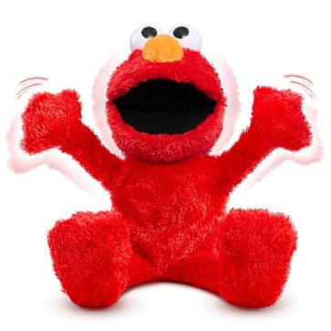
The original Tickle Me Elmo was one of the most iconic toys of a generation, with one million Elmos snapped up back in 1996 when it launched.
Now, Elmo is set to giggle off the shelves again with the launch of the new Sesame Street Tickle Me Elmo Giggle Max.
More than 4 inches taller than the original, standing at 18 inches, the Tickle Me Elmo Giggle Max is more interactive and giggly than ever before, with new phrases and a new arm waving motion as he laughs.
He is suitable for youngsters aged from 18 months – and the more you tickle him, the more he giggles!
- Tickle Elmo’s belly, left foot, or right foot to start the fun.
- Elmo giggles, his arms move up and down, his mouth opens and closes, and his whole body shakes with excitement.
- Hear him say cute phrases including “That tickles Elmo!”, “Whoo-hoo!” and “AGAIN!” – he may even develop a few hiccups!
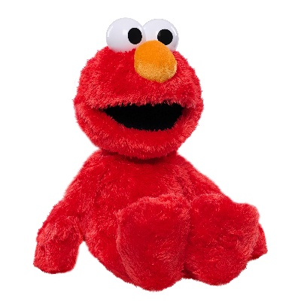
Elmo fans of all ages will love cuddling and tickling this beloved Sesame Street icon.
Tickle Me Elmo Giggle Max is now available to pre-order from Smyths Toys at a special price of £39.99 and will be in stores from early August 2026.
High-resolution imagery can be downloaded for use here.
Samples are available - contact bernie@evolution-pr.co.uk.

