Active-Tots™:
the building blocks of play!

TP Toys introduces a range of inter-connecting wooden play equipment enabling toddlers aged 12m+ to explore, move and learn as they climb, swing, hide and balance!
Based around the philosophy of renowned Paediatrician and Infant Educator, Emmi Pikler, this beautifully crafted range focuses on the concept of independent learning for babies and toddlers and at its core, the Pikler Triangle climbing frame. Developing and encouraging gross motor skills, strength, agility and movement from a young age, the range features multiple positions and configurations, with each of the pieces of equipment having interconnectivity built in. This offers parents the flexibility of being able to create whatever combination required to enhance their child’s development. Each also has the capability to be folded and stored simply and easily, enabling parents to adapt the system to large or small indoor spaces plus they all include simple, intuitive locking-pin design for ease of assembly.
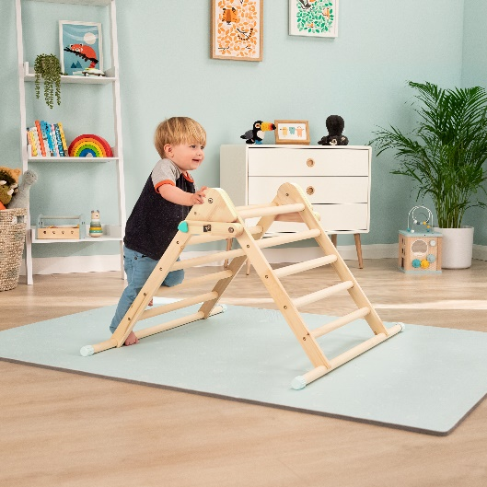
A fun way to encourage inquisitive toddlers to stand and climb one rung at a time, the Wooden Climbing Triangle (RRP £69.99) is the centerpiece of the Active-Tots range. With anti-slip rubber feet providing stability for mini climbers and also protection for floors, the stunningly simple and aesthetic design is deceptively robust and crafted from FSC® sustainable wood so is a natural play solution for both your home and the environment. Expand and enhance a toddler’s development by connecting the Wooden Climbing Bridge & Slide (RRP £99.99) to the Climbing Triangle to create a whole new play adventure!
This adaptable, dual use slide/bridge adds an extra dimension and learning possibilities plus connects with the Indoor Wooden Climbing Cube (RRP £119.99) encouraging toddlers to crawl, climb up and over plus use as a fun play space relating to a child’s learning ability. Whether its hiding in a den, playing peek-a-boo or pretending being in a space ship, the range offers limitless creative opportunities.
…/…

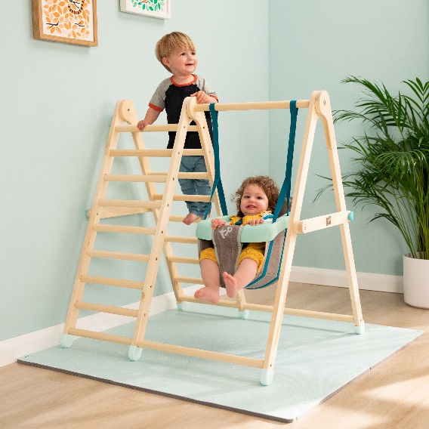
Designed specifically for babies and toddlers, the indoor Wooden Climb and Swing (RRP £179.99) combines a soft, supportive foldaway swing seat to accommodate infants aged 6m+ with a compact, climb frame for older toddlers to get active and practice climbing skills alongside their younger sibling.
Simple, ergonomic and crafted from sustainable wood, the curved Indoor Wooden Balance Board enhances and complements the modular Active-Tots play system by helping children practice their balancing skills and poise whilst sparking imaginative play as they develop. Active tots can make believe the board is a seat, slide, bridge, racetrack, table or whatever they imagine it to be!
Providing super soft protection, the Active Tots squishy foam Play Mats are a perfect addition to any Active-Tots climbing frame, protecting adventurous toddlers as they learn to crawl, walk and climb. Durable for bouncy tots, the EVA foam tiles are 1.4cm thick and the tough (but soft) material is designed to resist wear and tears from kids and grown-ups alike!
-Ends-
Notes to editors:
The Active-Tots range is available now. For more information head to: www.tptoys.com

