Bluey Pool Time Playset makes a splash

Inspired by “The Pool” episode from the hit show Bluey, fans will love the latest fun filled toy, the new Bluey Pool Time playset.

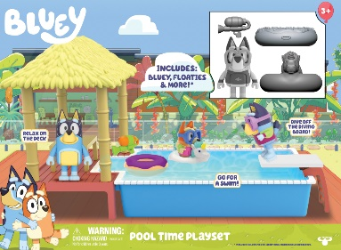
Kiddos can make up their own playful adventures and recreate some of their favourite and hilarious pool time moments from Bluey, the hit Australian animation loved by kids, parents, Hollywood stars and British celebrities.
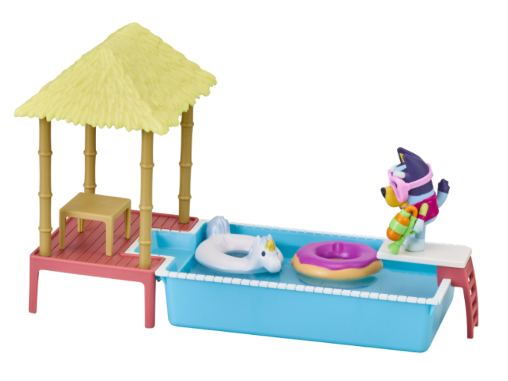
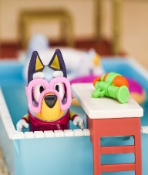
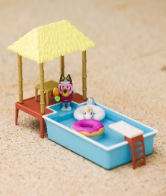
Dive Bluey off the diving board, pop her in the donut, have some pool fun in her unicorn floatie, or pop the goggles on Bluey’s face and have a pretend water fight with the water blaster! When exhausted by all the pool fun, Bluey can relax on the deck under the cabana.

For extra “real life” fun the Pool can be filled with water for an even more realistic play experience!

The Playset contains an articulated Bluey figure - pool ready in her swimsuit - a pool, a cabana and five pool toys and accessories - a donut floatie, a unicorn floatie, swim goggles, water blaster and dive board with ladders.

Price: Bluey Pool Time Playset £19.99
Age: 3-5yrs
Stockists: Smyths, Argos, The Entertainer and major supermarkets

Ends

For further information, please contact Playtime PR:
Chloe Bailey: chloe@playtimepr.com | 07970 649008
Chrissie Williams: chrissie@playtimepr.com | 07715 816363
Ceriann Smith: ceriann@playtimepr.com | 07966 010449

About Bluey
Bluey follows a loveable, inexhaustible 6-year-old Blue Heeler pup, Bluey, who lives with her Mum, Dad and her 4-year-old little sister, Bingo. The series showcases the everyday events of family life – from going to a restaurant and visiting the hairdressers to catching the bus or having a playdate – and celebrates these moments, turning ordinary experiences into extraordinary imagination-packed adventures.

Bluey is produced by Ludo Studio for ABC KIDS (Australia) and co-commissioned by ABC Children’s and BBC Studios. Financed in association with Screen Australia, Bluey is proudly 100% created, written, animated, and post produced in Brisbane Queensland, Australia, with funding from the Queensland Government through Screen Queensland and the Australian Government.

About Moose Toys
Moose Toys exists to make children Superhappy, it’s at the heart of everything we do. The team has innovation in its DNA and is famous for the design, development and manufacture of award-winning toys that continue to disrupt the market! Moose Toys leads in categories including collectibles, craft, dolls, games and youth electronics and is consistently recognized as the most creative company in the industry. We are a family-run business, but that doesn't mean we are small-time. We shook up the toy industry in 2014 with the global phenomenon Shopkins, and through these pint-sized characters, we reinvigorated the way children play. Not satisfied to stop at toys, we have also stretched ourselves into creating content, entertainment and making worldwide licensing deals. Moose calls Australia home, but our 500-strong team is scattered globally, spreading the Superhappy.

