PRESS RELEASE EMBARGO: 7th March 2023

Lansinoh, global leader in maternal health and support, adds new Maternity Pads to their Birth Preparation & Recovery product range. Renowned for their postpartum and breastfeeding solutions, Lansinoh are pleased to announce the extension of their award-winning Birth Preparation & Recovery portfolio with their new highly absorbent Maternity Pads, designed specifically to protect new mums in the days and weeks after giving birth.
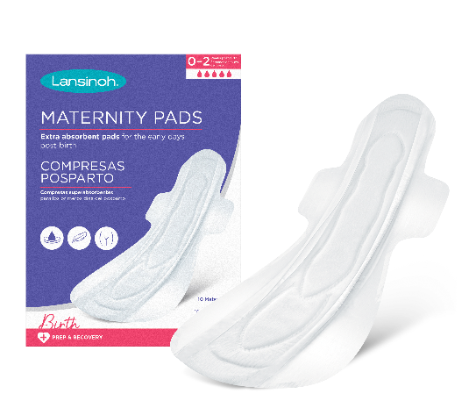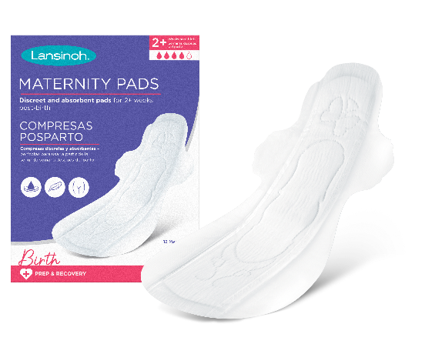
Available in two protection levels: Extra Absorbent and Discreet & Absorbent, the new Maternity Pads are crafted from soft, breathable and dermatologically tested materials and provide new mums with the comfort, discretion, and protection they need for their postpartum recovery.

All women experience bleeding after the birth of their baby (whether they have a vaginal or caesarean birth) called Lochia. There are 3 stages of lochia – typically lasting up to 6 weeks with a woman’s needs changing as they progress through these stages. For many women, postpartum bleeding is heavier than a typical menstrual period, particularly in the first 2 weeks requiring a degree of protection not offered by traditional menstrual or bladder leakage pads.

Developed specifically for Lochia, Lansinoh’s Extra Absorbent Maternity Pads are anatomically shaped, longer and wider at the back, with leak guard protection from the heaviest bleeding in those first few weeks. As new mums transition from the first phase of lochia to the second and third with a lighter flow, their absorbency needs are reduced. Coupled with getting into their new routine as a mum and being more active, the smaller Discreet & Absorbent Maternity Pads are designed to still offer protection with an advanced liquid-lock core, but with a slimmer pad.

Key Information:
- Developed with input from mums and healthcare professionals
- Soft and breathable, designed for tender, postpartum skin
- Fragrance free and naturally contoured for a comfortable fit post childbirth
- Adhesive back and wings to keep in place securely
- 95% of testers reported the Extra Absorbent Maternity Pads had very good or extremely good absorbency levels
- Extra Absorbent Maternity Pads: 10 pack. RRP: £2.49
- Discreet & Absorbent Maternity Pads: 12 pack. RRP: £2.49
- Available from lansinoh.co.uk and amazon.com

How to safely and effectively manage postpartum bleeding
- Cleanse: Cleanse the perineal area when visiting the bathroom using the Lansinoh Post-Birth Wash Bottle
- Protect: Place Lansinoh Maternity Pad in pants to protect clothing, changing every few hours
- Relieve: Place the Cold & Warm Post-Birth Relief Pad beneath the maternity pad for highly effective drug-free pain relief
- Soothe: Spray Lansinoh Organic Post-Birth Relief Spray onto Maternity Pad to help soothe and relieve discomfort

ENDS
Contact anna@lansinoh.co.uk to request samples, further information and additional imagery.

About Lansinoh: For nearly 40 years, new mothers have trusted Lansinoh to support and care for them while they enter the messy magic of motherhood. Born from one mother’s realisation that as they tirelessly care for their babies, parents often go without the support they need and deserve. That’s why Lansinoh proudly stands with mothers all over the world. The brand’s journey started (and continues) with the multi-award winning, healthcare professional recommended HPA Lanolin Nipple Cream. Today, it offers a comprehensive collection of solutions that help new parents navigate pregnancy, birth, breastfeeding, and pumping. Visit https://lansinoh.co.uk/ for the full range of products and more information or follow on social: @lansinohfamily

