PRESS RELEASE 18th September 2023

Lansinoh, global leader in maternal health and support, add NEW
C-Section Hydrogel Pads to award-winning Birth Preparation & Recovery range

Renowned for their postpartum and breastfeeding solutions, Lansinoh announce their first recovery product designed exclusively for C-Section mums, developed to help protect the incision site and minimize friction from clothing while providing soothing, cooling relief for tender, healing skin.

A survey of 200 C-Section mums* showed that 71% were very anxious to protect their C-Section wound, with 77% of new mums worrying that their wound would impact their ability to do things. Designed provide new mums with more confidence as they become more active, a home user trial** scored the Lansinoh C-Section Hydrogel Pads an impressive 9.2 out of 10 for protection, with 92% saying they would use again, or recommend to others.

69% of the same audience* found their wound was either itchy or painful around the area as it healed – a common effect even after it has closed, and stitches removed. Lansinoh’s C-section Hydrogel Pads were rated 7.9 out of 10 for their cooling properties and 7.8 out of 10 for providing instant relief.

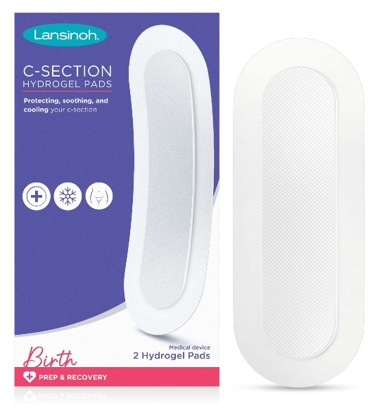
Key Product Information:
- For use from 10 days postpartum when the wound is closed and staples/stitches have been removed/dissolved
- Cushioned gel pad minimizes friction from clothing & helps keep wound clean
- Provides cooling & soothing effect as incision continues to heal
- Can be placed in the fridge for extra cooling effect
- Designed to stay in place for up to 72 hours
- Crafted from LDPE adhesive backing with a 50% hydrogel island
- Transparent and slim, latex and DEHP free
- RRP: £14.99 (2 pack)
- Now available at lansinoh.co.uk and John Lewis

* Bourdillon K, Kirsten Granger, Morgan McCabe, Lisa Herz, Reasons for C-Section and Experiences of Recovery: A Qualitative Survey of US-Based Mothers
** Home User Trial Lansinoh’s Soothies® C-section Recovery Pads. Mumsviews. 2022

ENDS

Contact anna@lansinoh.co.uk to request samples, further information and additional imagery.

About Lansinoh: For nearly 40 years, new mothers have trusted Lansinoh to support and care for them while they enter the messy magic of motherhood. Born from one mother’s realisation that as they tirelessly care for their babies, parents often go without the support they need and deserve. That’s why Lansinoh proudly stands with mothers all over the world. The brand’s journey started (and continues) with the multi-award winning, healthcare professional recommended HPA Lanolin Nipple Cream. Today, it offers a comprehensive collection of solutions that help new parents navigate pregnancy, birth, breastfeeding, and pumping. Visit https://lansinoh.co.uk/ for the full range of products and more information or follow on social: @lansinohfamily

