Introducing NEW Nairn’s Gluten Free Salted Caramel
Oat Biscuit Breaks
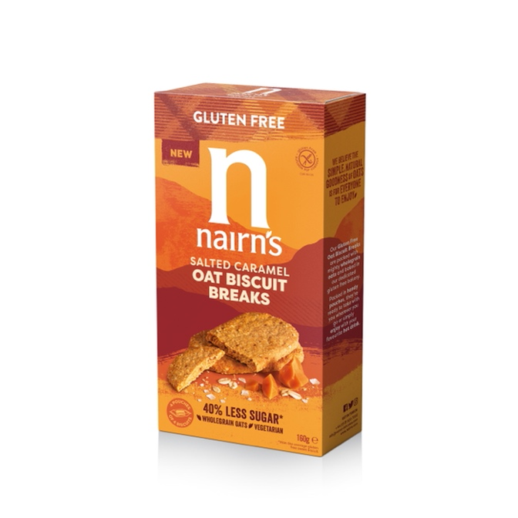
Bringing ‘healthier indulgence’ to the ever-popular gluten free, lower sugar range!

The launch of Nairn’s Gluten Free Salted Caramel Oat Biscuit Breaks brings one of the most popular flavours of recent years into the Nairn’s award-winning gluten free sweet biscuit range. Baked to golden crumbly perfection, the simplicity of oats is combined with subtle, buttery caramel fragments and a hint of sea salt to create the irresistible ‘sweet savoury’ taste sensation.
As you’d expect, this new addition follows the same delicious, natural and wholesome ethos the brand is so well known for. With all the benefits of wholegrain oats, Nairn’s Salted Caramel Oat Biscuit Breaks are also high in fibre, contain 40% less sugar than the average gluten free biscuit and contain no artificial colours or flavours. Baked in Nairn’s dedicated gluten-free bakery, they are suitable for those following a gluten free diet, though they’re so irresistibly good, you may be tempted to keep the whole packet to yourself!

Nairn’s Salted Caramel Oat Biscuit Breaks are a great option when you’re looking for a delicious guilt-free treat - pop into a desk drawer or handbag for a quick snack, enjoy as the perfect partner to a cuppa with friends or indulge in a moment of ‘me time’. But the possibilities really are endless, and perhaps the most versatile use of all is as a great blank canvas for a dessert. Top with a sweet spread of your choice and some nuts, crumble up to add some crunch to Greek yoghurt, or enjoy with lashings of cream cheese and berries or jam as super-quick cheesecake style serve. Why not sandwich with your favourite ice cream or even try the American classic with marshmallows over the fire for a s’mores experience? The options are endless!

Lower in Sugar
According to category reports, Brits spent an extra £160.8m on biscuits in 2020, which amounted to an extra 144 million packets being cracked open ^{[1]} - it’s fair to say that we are still a nation of biscuit lovers! Great tasting products that provide a lower sugar alternative are definitely welcome as the government continues to tackle sugar consumption within the UK.

Health benefits at a glance:
✔ Packed full of gluten free wholegrain oats
✔ 40% less sugar than the average gluten free biscuit
✔ Contains no artificial colours, flavours or preservatives
✔ High in fibre
✔ No GM ingredients
✔ Suitable for vegetarians
✔ Certified Gluten Free by Coeliac UK
✔ No hydrogenated fat

Nairn’s Gluten Free Salted Oat Caramel Biscuit Breaks (RRP £1.80, 160g) will be available from the 27th of August in Sainsbury’s stores.

Also available in the Nairn’s Gluten Free Biscuit Breaks Range:
- Oat Biscuit Breaks - Chocolate Chip, Fruit, Stem Ginger, Syrup
- Chunky Oat Biscuit Breaks - Apple & Cinnamon, Blueberry & Raspberry, Dark Chocolate & Coconut, Dark Chocolate & Mint (NEW)

END

For further press information, images or samples please contact Annabel Dodd or Ella Campbell at CCD PR on 020 7434 4100 or email ella@ccdpr.com
To view the full range from Nairn’s, please visit: www.nairns-oatcakes.com

Notes to Editors:
Edinburgh based Nairn’s has been baking with oats since 1896. They are the UK’s number one producer of oatcakes, as well as one of the leaders in branded Gluten Free products with an extensive, growing range that now includes oatcakes, crackers, flatbreads, sweet biscuits, cereals and snacks. Staying true to their roots, all Nairn’s products are deliciously simple, natural and wholesome and do not contain any artificial colourings, flavours or preservatives.
There has been a great deal of research into the positive health and lifestyle benefits of oats. Oats are high in fibre and contain complex carbohydrates that give a natural and wholesome boost. Oats have also been shown to have a beneficial impact on the gut which is widely referred to as the “second brain”.

In 2017, Nairn’s opened the doors of its bigger, ‘state of the art’ gluten-free bakery in Newtongrange, Midlothian, in response to growing demand for Nairn’s Gluten Free products. The new bakery has provided the capacity and technology to expand the range with an ongoing pipeline of new products.

