AUDIO PLATFORM FOR KIDS, YOTO, LAUNCHES PHONICS LESSONS TO ASSIST SPEECH, LISTENING AND READING DEVELOPMENT AT HOME

- Government statistics show attendance in education and early years settings during the coronavirus (COVID-19) outbreak dropped to as low as 0.6%¹ in the UK
- Yoto to assist in strategic teaching for early learners at home
- Phonics instruction plays a key role in helping students comprehend text

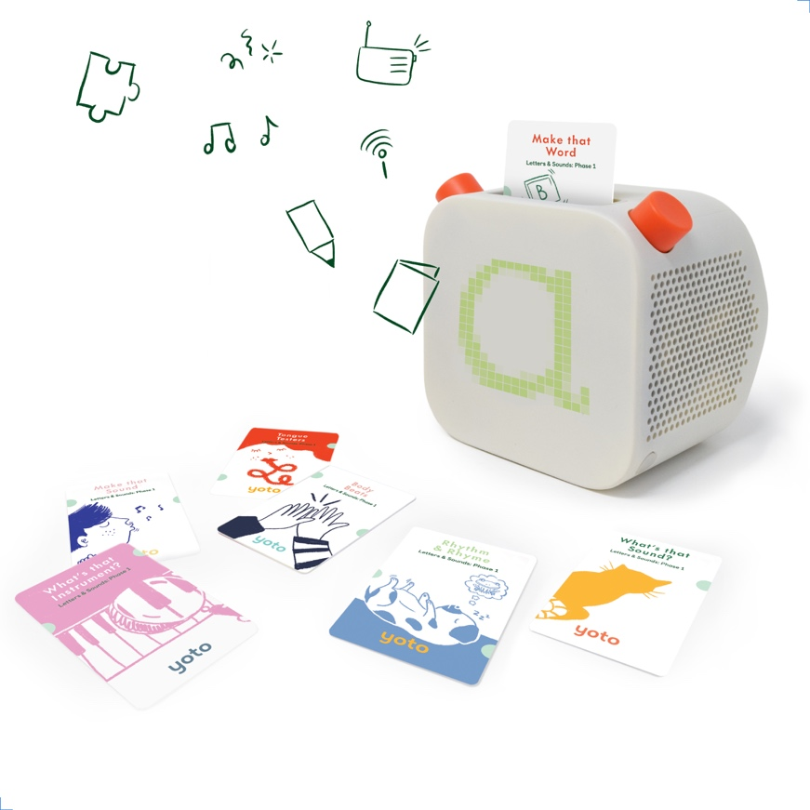

Kids audio platform Yoto has announced its new Phonics pack, designed to assist early learners to enhance their speech, listening and reading skills at home.

Phonics involves the relationship between sounds and their spellings. The goal of phonics instruction is to teach students the most common sound-spelling relationships so that they can decode, or sound out, words. This decoding ability is a crucial element in reading success.

With attendance in education and early years settings during the coronavirus (COVID-19) outbreakdropping to as low as 0.6% in the UK, home-learning has never been more important; particularly for young children. Learning the building blocks of letters at a young age unlocks their longer-term linguistic and cognitive capabilities, with phonics being an important tool for learning

Starting with phase one, the Yoto phonics cards are designed based on the government’s official ‘Letters and Sounds’ phonics programme, to support pre-school children (aged 2 - 4/5) as they start to develop their reading skills. They help children develop their speaking and listening skills through seven activities that introduce them to fundamental phonics concepts: environmental sounds, instrumental sounds, patterns/rhythm, rhyming words, alliteration, vocal sounds and oral blending/segmenting; all of which are the building blocks of reading.

The cards can be activated easily on Yoto Player; a connected speaker designed to safely give children full control over their listening, by entertaining and educating them while reducing screen-time. Simply insert one of the cards, and unlock a world of imaginative learning and development.

Ben Drury, CEO and co-founder of Yoto, says “Learning and development are vital components for a healthy childhood, and ultimately map out the future abilities and possibilities for any individual. The unfortunate arrival of COVID-19 has at times left parents - including me - with very limited access to teachers and tools to develop these skills, which for many I’m sure had led to a feeling of frustration. At Yoto, we want to alleviate this by providing educational and fun content that young learners can engage with and enjoy at home with their loved ones”.

The phonics cards are available now for £29.99 from www.yotoplay.com and Amazon.co.uk.

Yoto Player is available to buy from www.yotoplay.com with an RRP starting from £79.99. For more information please visit www.yotoplay.com.

The smartphone Yoto parents app is available to download for free on iOS and Android.

-ENDS-

Notes to editors
¹Source:https://www.gov.uk/government/publications/coronavirus-covid-19-attendance-in-education-and-early-years-settings

Media contact
For more information please contact the team at W Communications at yoto@wcommunications.co.uk.

About Yoto
In 2015 inspired by Montessori principles, as well as the cassette players of their youth, Ben Drury and Filip Denker thought up the idea of a connected, screen-free audio device that children could be fully in control of using physical smartcards.

With no experience in hardware, electronics or industrial design, but liking the idea of a challenge, they got to work prototyping a basic device and started testing with their own families and friends.

An award-winning industrial designer joined the team in 2016 and helped develop their hacked-together prototype into a product for market release. With a more stable concept in hand, they launched a Kickstarter campaign for the Yoto Player in November 2017 and achieved full backing in a few days.

With help from their Sheffield based manufacturing partner, 2018 was spent producing and fulfilling the first-generation Yoto Player which sold out in August 2019. Raising investment off the success of this model, the new Yoto Player has been created with globally renowned design partner Pentagram. Yoto Player is the brand’s first product release of 2020, building on its already successful audio ecosystem

