PRESS RELEASE

Dualit Introduces New Fuss-Free ESE Coffee Pods to its
Popular Coffee Collection
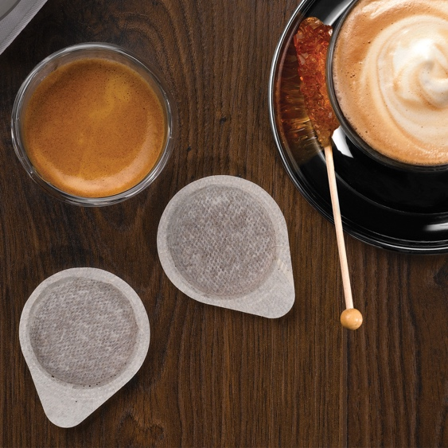

With many of us preferring the taste of loose ground coffee but craving the convenience of a coffee pod, iconic British appliance brand Dualit has added to its coffee range to cater to the demand for a mess-free alternative. Dualit’s Easy Serving Espresso Pods (ESE Coffee Pods) are not only convenient but are made using the highest quality 100% Arabica beans. Each pod holds 7g of pre-dosed, pre-tamped, expertly roasted ground coffee; the perfect amount for a single serving. Whether preparing a coffee for one or for friends and family, the new ESE pods are quick and easy to use whilst importantly not compromising on the premium taste and blend. To ensure flavour is maintained, Dualit’s ESE Pods delicately seal the coffee in filter paper designed to preserve it’s characteristics, then are individually sealed to retain freshness and that all-important ‘just-roasted’ taste. Coffee lovers who are often short on time can rely on the ESE pods to provide a perfectly balanced, deliciously rich yet smooth espresso in a quick and mess-free manner.

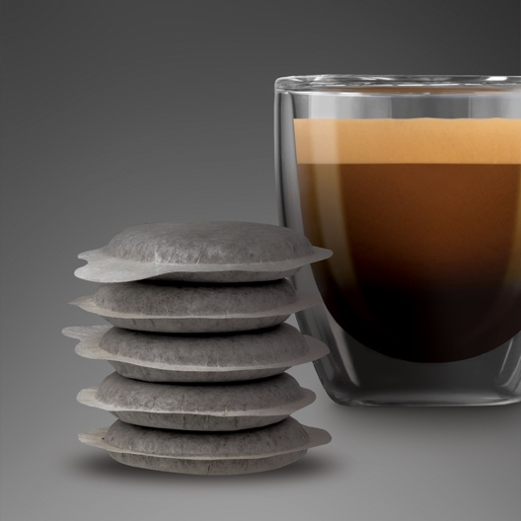

ESE Coffee Pod Flavours
Dualit’s mixed and single origin coffee pods combine the flavours of Central and South America to deliver tasting notes that linger on the palate. ESE Coffee Pods are compatible with ESE Pods Machines including Dualit’s 3 in 1 and Espress-auto coffee machines.
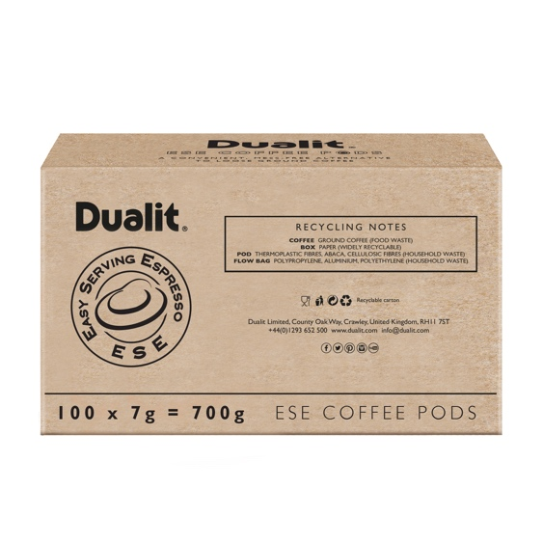

Colombian – Price £19.99
A single origin coffee, infused with notes of sweet tangerine, raw sugar and roasted walnuts. It’s smooth and light with a refreshingly mellow, clean character and a citrusy aroma.

Intense Espresso – Price £19.99
A dark roasted blend of high grown Central and South American coffees that is rich and dramatic, offering notes of sweet fruits and roasted nuts, with a chocolatey finish.

Lungo Americano – Price £19.99
Lungo is grown in rich, volcanic soil, with cedar notes, sweet tropical fruit aromas and a rich, indulgent finish.
Decaf – Price £24.95
Decaf is a light bodied coffee with a very mild acidity, delivering subtle chocolate notes, a sweet, nutty finish and a refreshing piquant taste.

Perfect Partners

Dualit 3 in 1 Coffee Machine - from £179.99
The groundbreaking Dualit 3 in 1 Coffee Machine offers coffee shop quality lattes, cappuccinos and espressos. Unique to the market, Dualit's patented multi-brew system offers the freedom to choose from ground coffee, mess-free ESE Pods, Nespresso®* Capsules and Dualit's convenient and patented Coffee Capsules.
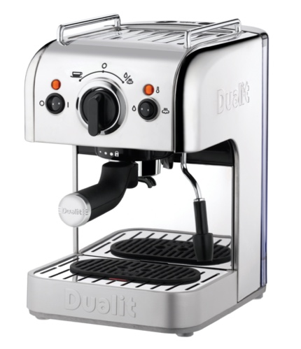

Dualit Espress-auto Coffee and Tea Machine - £224.99
The award-winning and versatile Dualit Espress-auto Coffee and Tea Machine offers the freedom to choose from a multitude of different brewing options. Users can select from ground coffee, mess free ESE Pods or convenient compatible coffee capsules from Dualit or Nespresso®*. It also boasts a full café experience with an adjustable frothing arm, a 15-bar pump and patented Pure Pour® for a smooth and consistent flow of espresso with a dense crema.

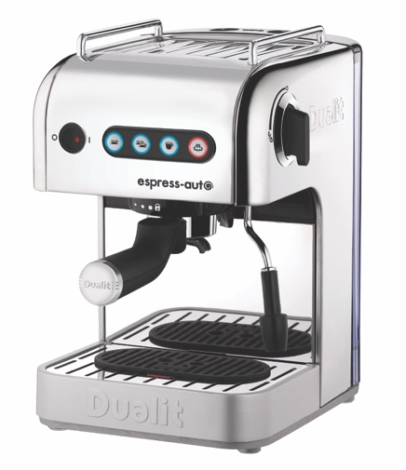

Stockists
Available from Dualit, www.dualit.com and Amazon

ENDS
Notes to Editors

*Nespresso® trademark is owned by Société des Produits Nestlé S.A.

For more information, high resolution images or samples for review, please contact: Sophie Anderson or Francesca Sanchez at Sellers PR on 01962 977 950 or email: sophie.anderson@sellerspr.com l francescsa@sellerspr.com

