NARUTO SHIPPUDEN meets PLAYMOBIL
24 new figures for all anime enthusiasts!
The popular anime series NARUTO has been flickering across screens for two decades now, fascinating fans of all ages all over the globe. Based on the manga comic of the same name, the series shows the exciting journey of the ninja Naruto. In time for this special birthday, 24 characters from the hit series NARUTO SHIPPUDEN will be available as lovingly designed figures from PLAYMOBIL, starting in October.
Of course, the namesake of the series is at the forefront: the congenial Naruto Uzumaki, whose greatest goal is to become Hokage – the leader of his village. His friends, the determined Sasuke Uchiha and the considerate Sakura Haruno, accompany Naruto on his adventures. In addition to the three main characters, there are 21 other exciting figures to discover, including the inscrutable Itachi Uchiha and Pain, the leader of the criminal organisation Akatsuki. Minato, Naruto’s father, and the shy Hinata cannot be missing here either, of course.
Whether for recreating legendary moments from the cult series, for inventing entirely new, exciting scenes or for simply adding it to the collectables-showcase, the NARUTO SHIPPUDEN PLAYMOBIL edition is an absolute must-have for all anime fans.
And if you still can’t get enough of NARUTO meets PLAYMOBIL with the 24 wonderful figures from NARUTO SHIPPUDEN, stay tuned. The exciting collaboration between PLAYMOBIL and NARUTO will continue!
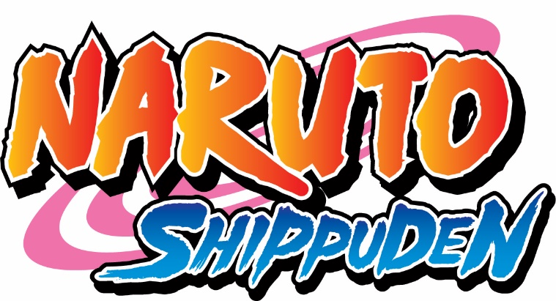

©2002 MASASHI KISHIMOTO / 2007 SHIPPUDEN All Rights Reserved.

The NARUTO SHIPPUDEN PLAYMOBIL edition at a glance:
24 individual figures from the hit series NARUTO SHIPPUDEN | including the main characters Naruto Uzumaki, Sasuke Uchiha and Sakura Haruno | many other exciting figures from the hit series | recommended age: 5-99 | available fall 2022

Release date: Jan 2023

71096 Naruto
71097 Sasuke
71098 Sakura
71099 Kakashi
71101 Obito
71102 Kakuzu
71105 Yamato
71106 Hidan
71113 Iruka
71115 Shizune
71117 Kisame
71118 Rock Lee

Release date: May 2023

71100 Itachi
71103 Gaara
71104 Madara
71107 Shikamaru
71108 Pain
71109 Minato
71110 Hinata
71111 Might Guy
71112 Suigetsu
71114 Tsunade
71116 Killer Bee
71119 Asuma

