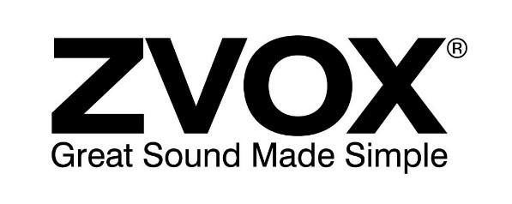

ZVOX Continues To Lead the Industry with Generation IV
Dialogue Clarifying Technology
By Thomas Hannaher, Founder & CEO, ZVOX Audio
Since our founding in 2003, ZVOX has been on the cutting edge of technologies that improve sound. While we began as a company dedicated to perfecting the TV soundbar (which we did), over the past six years we’ve evolved into a full-fledged “hearing company” – dedicated to improving voice and dialogue clarity in TV programming. We recognized a growing frustration among consumers of all ages about the difficulty of understanding the dialogue on TV programming. Younger people often solved the problem by watching with the closed-caption features, while older viewers simply raised the volume of their TVs – neither ideal solutions. But with the development of our proprietary dialogue clarification technologies, ZVOX has been leading the industry by integrating these technologies into a wide variety of products, like our critically acclaimed sound bars, simple voice-enhancing TV speakers embraced by baby boomers, affordable noise-cancelling headphones and hearing aids. With the debut of our latest TV speaker, the AV157, ZVOX has introduced the fourth generation of our Dialogue clarification technology, benchmarking this important emerging category.
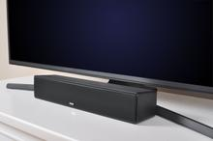
Introducing AccuVoice Generation IV… SuperVoice!
The arrival of the breakthrough ZVOX AV157 Speaker marks the first-ever implementation of our Generation IV AccuVoice technology, with six levels of AccuVoice boost and six levels of the ZVOX proprietary “SuperVoice” boost – 12 levels of dialogue clarification altogether. While our AccuVoice technology focuses on Dialogue clarity, the goal of our new SuperVoice algorithm is to both soften and reduce the levels of non-voice sounds in the soundtrack. The result is a new level of dialogue clarity and understanding. By relegating non-dialogue elements to the background (while not completely eliminating them), voices take on a “front and center” position for the listener.
To get a better understanding of how it all works, let’s go back and take a quick look at the first three generations of our patented AccuVoice technology.
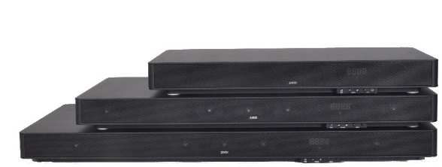
Generation I: The Origin of Dialogue Emphasis…
In 2011, ZVOX introduced two home theater systems with an important new feature called Dialogue Emphasis (DE), our first successful foray into improving the clarity of TV dialogue. The SoundBase 555 and 580 were the first speakers to use hearing aid technology to clarify the spoken word. By isolating “consonant frequencies” and manipulating them with equalization and compression, DE further separated the dialogue from the other sounds on the soundtrack.
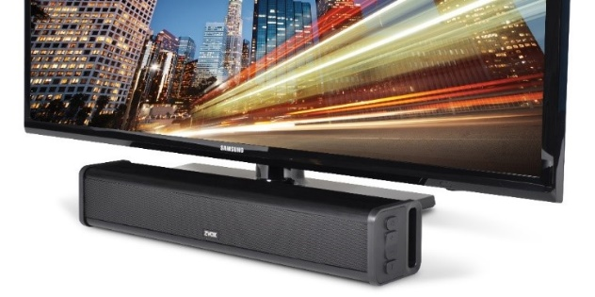
Generation II: The Refinement Continues…
With Generation I, the DE also boosted other signals in the key consonant frequency ranges, which left a good deal of room for improvement in terms of overall sound quality and dialogue clarity in particular, so in 2016 we introduced a patented technology called AccuVoice – which separated dialogue from the other components in the soundtrack. AccuVoice allowed us to manipulate the voice signals while leaving music, traffic noise and other soundtrack elements relatively unaffected. AccuVoice was a big jump from our Generation I DE process, and it led us to a dramatic step: the creation of a small TV speaker whose primary task was to clarify dialogue. The AccuVoice AV200 Speaker immediately became our all-time best-selling product, and reached the #1 slot on Amazon’s list of best-selling sound bars. This product was enthusiastically welcomed, particularly by baby boomers suffering from mild hearing loss.
Generation III: Addressing the Needs of the Hearing-Impaired Community
While the AccuVoice AV200 was truly a breakthrough product, we quickly found that it wasn’t quite enough for customers with more advanced hearing issues. Some people simply needed more boost than others. So in 2018 we introduced the first AccuVoice speaker with six levels of dialogue boost, the AV203. The Generation III AccuVoice Speakers with multiple levels of dialogue boost dug very deep into the “bag of tricks” that have been used by the audiology industry to create effective hearing aids. Using advanced algorithms, these speakers manipulated aspects of audio well outside of equalization and compression to create unprecedented levels of dialogue clarity, literally “putting an edge on” the spoken word. In addition, ZVOX further compressed the dialogue to a level that doesn’t require the user compensate for volume changes while they are trying to hear dialogue. Non-dialogue actually maintains more of its original dynamics so that when there is no dialogue, the soundtrack still has some naturalness and provides the emotional impact the creators intended.
ZVOX Leadership
Today, virtually every manufacturer of TV sound systems is trying to imitate the technology we use in our AccuVoice Speakers with some kind of voice clarification technology. We’ve auditioned most of these products and have not found any that have been able to replicate what we have accomplished.
To be honest, the results of these technological breakthroughs are much easier to hear than to describe. So please take a listen for yourself! You can get a pretty good idea by watching this short video.

