Life is a sustainable adventure with Falk Toys!

Make the great outdoors your back yard with the new range of sustainable ride-on toys from Falk!

Designed and built in France, Falk Toys has a strong heritage of producing child-size replicas of vehicles kids see everyday in the fields and on the farms around them including JCB, Claas, Massey Ferguson and New Holland.

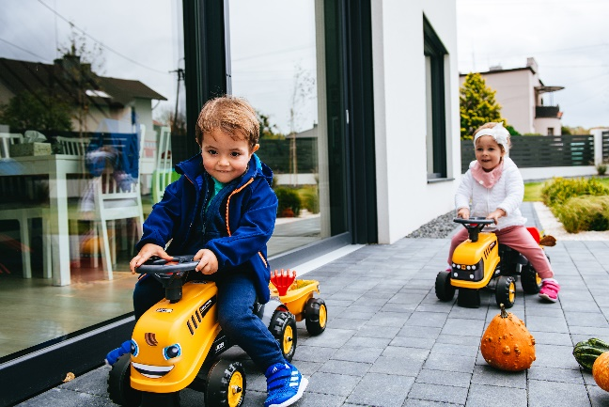
Created to enhance and reflect the environment, Falk Toys are an ethical choice for parents who believe that childhood is made for being active, running, pedalling, jumping in puddles and getting dirty – building lifelong memories with outdoor play. Nature is the ultimate playground as a child grows and develops and Falk has designed a battery-free, easily disassembled range that incorporates 70% sustainable, recyclable packaging, uses 30% recyclable plastic elements and ensures that all scraps are crushed into re-usable flakes to go back into production!

With moving gear stick and opening seat compartment to store everything a mini adventurer on-the move needs to get around, the new Falk London Bus Ride On RRP £37.99 comes in distinctive London Bus red with sturdy wheels and customisable license plate for hours of ride-on fun for ages 1-3!

Budding builders aged 1-3 will feel right at home with the Baby JCB Ride-On RRP £49.99! Complete with sticker set, detachable wheeled trailer with slot-in role play rake and shovel accessories , this sturdy ride-on is a perfect way for small feet to propel themselves around and enjoy the great outdoors!

Kids can get stuck in with the new ride-on Super Builder Crawler Excavator RRP £69.99 which includes an opening seat, detachable trailer with multiple tool play accessories, and red brick sand moulds for hours of role play fun. Children aged 3+ can move the fully articulated mechanical shovel and powerful excavator arm up and down while rotating the seat 360 degrees for optimum digging action!

Older adventurers aged 2-5 can get to grips with the new Claas Backhoe with trailer ride-on RRP £114.99 as they pedal and steer around, making it easy to manage any project, big or small! An exact replica of the Claas Arion 410, the ride-on is designed to inspire the imagination, the vehicle comes complete with working front shovel, detachable wheeled trailer, customizable license plate and specially designed ergonomic seat position.

