+
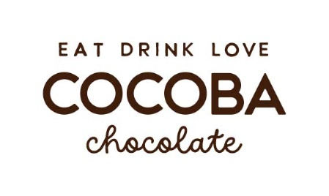
Cocoba Chocolate introduces the ultimate Easter egg collection…
Cocoba, the Kent-based chocolate company renowned for producing irresistible chocolate and hot chocolate gifts, has launched a range of indulgent and fun-filled Easter eggs and Easter goodies.
The Easter bunnies at Cocoba Chocolate have carefully thought up a selection of flavoured eggs for children and grown-ups alike. The array of products includes the Golden Caramel Egg, the Jazzie Milk Egg, the Candy-Coated Egg and the giant 4kg Egg. The Easter bunnies have also crafted a selection of Easter themed Hot Chocolate Spoons and Easter Bunny Hot Chocolate Bombes, both delicious in taste and beautifully presented.
Starting off the range is the immense 4kg Egg, an excellent Easter gift for a loved one who just loves chocolate. Priced at £99.95 this egg is ideal to share or to eat it all by yourself.
The Golden Caramel Easter Egg at £11.95 encompasses golden caramel in a smooth and creamy Belgian milk chocolate egg. A delicious Easter Egg for those with a sweet tooth.
To add a little extra crunch and colour, the Candy-Coated Egg at £11.95 is covered in tasty candy chocolate beans and comes in either milk or white chocolate to provide the winning combination for chocolate lovers this Easter.
Created by the Easter bunnies at the Cocoba Chocolate factory the Jazzie Milk Egg topped with vibrant rainbow sprinkles retails at £11.95, it also comes in a dairy-free milk chocolate alternative, a tasty treat that will jazz up anyone’s day.
Finally, it wouldn’t be Easter without a selection of Cocoba Chocolate’s Hot Chocolate Spoons. A popular choice is the Mini Easter Egg Hot Chocolate Spoon. Cocoba’s mini-Easter eggs have been added to a Belgian hot chocolate spoon to create a little more chocolatey goodness to a warming hot chocolate. The Hot Chocolate Spoons priced at £3.50 come with a variety of Easter toppings from fluffy marshmallow Easter chicks to marshmallow pink bunnies.
Please visit Cocoba Chocolate’s website for more information including the hot chocolate bombes, spoons and vegan product range at www.CocobaChocolate.com.
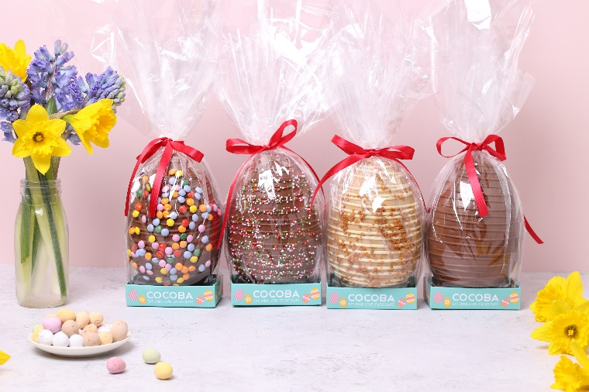
Selection of Easter Eggs from Cocoba Chocolate

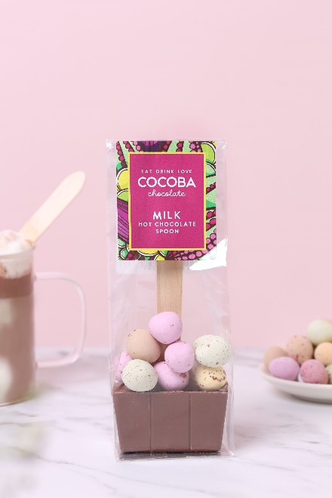
Cocoba Mini Easter Egg Hot Chocolate Spoon
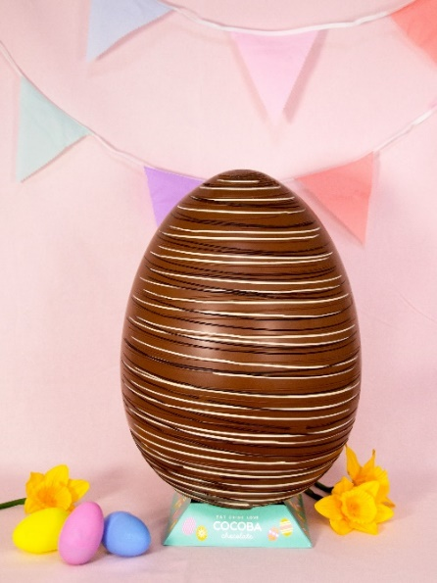
Giant 4kg Easter Egg
Notes to editors:
Cocoba’s chocolate products include Belgian hot chocolate, chocolate bars and lollipops, truffles and buttons, and a growing range of vegan chocolate.
Cocoba’s range is available from www.CocobaChocolate.com as well as Cocoba’s flagship chocolate café at the Bluewater Shopping Centre in Kent, independent farm shops, delis, John Lewis, Selfridges and more. All products are handmade in Kent.
For more information please contact:
Naomi James Cocoba Chocolate
Cocoba Chocolate Email: naomi@cocobachocolate.com
Instagram, Facebook, Pinterest, TikTok, Twitter: @cocobachocolate Web: www.cocobachocolate.com

