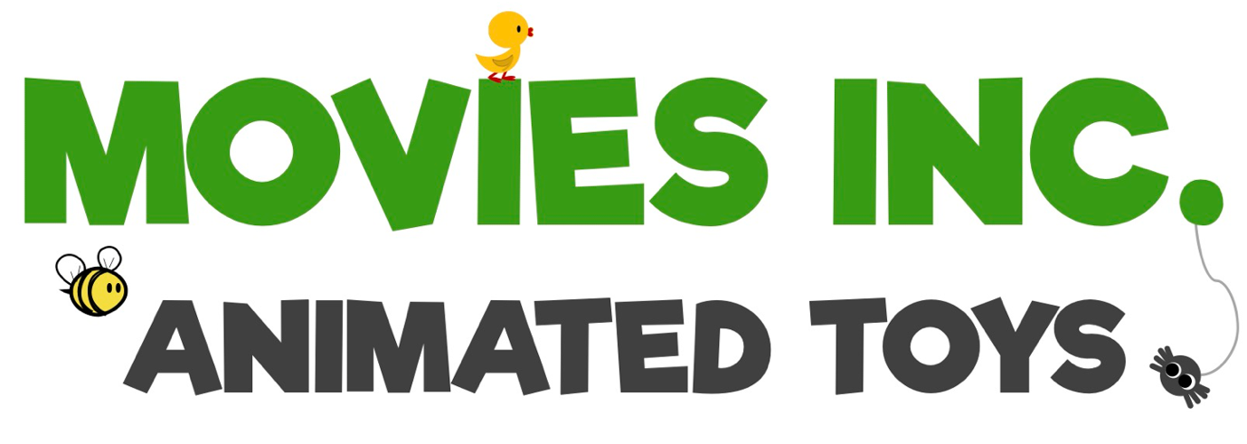

BLOG - INTRO

Hello, my name’s Pip (she/her) and my toy-story goes like this: about 12 years ago, whilst watching my young daughter’s hamster running in its wheel, I had an idea. What about if the wheel was a 'zoetrope'? (an early device for producing animation).

I set about prototyping at home and applied for a UK patent, which I got about 7 years later (..UKPO are s-low!).

The patent was for a couple of different designs and I started contacting pet-product companies to gauge interest. However, it occurred to me that perhaps there was a way to adapt the zoetrope for a child which might have better prospects – the idea of a push-along zoetrope was born.

That push-along zoetrope spawned more ideas and further prototyping. And the more people I spoke to, the more ideas and uses came to mind.

All these ideas have led to a lot of - enjoyable though :) - work!

So “MOVIES INC” was established and name derives its meaning for pre-school toys, all of which incorporate ‘moving pictures’ and make the move the toy to generate a movie.

Broadly/loosely this is a technology (albeit a low one!) - by combining the optical-illusion curiosities of yesteryear (zoetropes, mutoscopes, thaumatropes, flicker books and so on) with modern playthings, the toys have a fresh novelty which can be deployed in numerous ways.

Please read/see more at www.moviesinctoys.com.

