Chocolate infused with a zingy twist - Nairn’s NEW low-sugar option:
Dark Chocolate & Orange Oat Biscuits
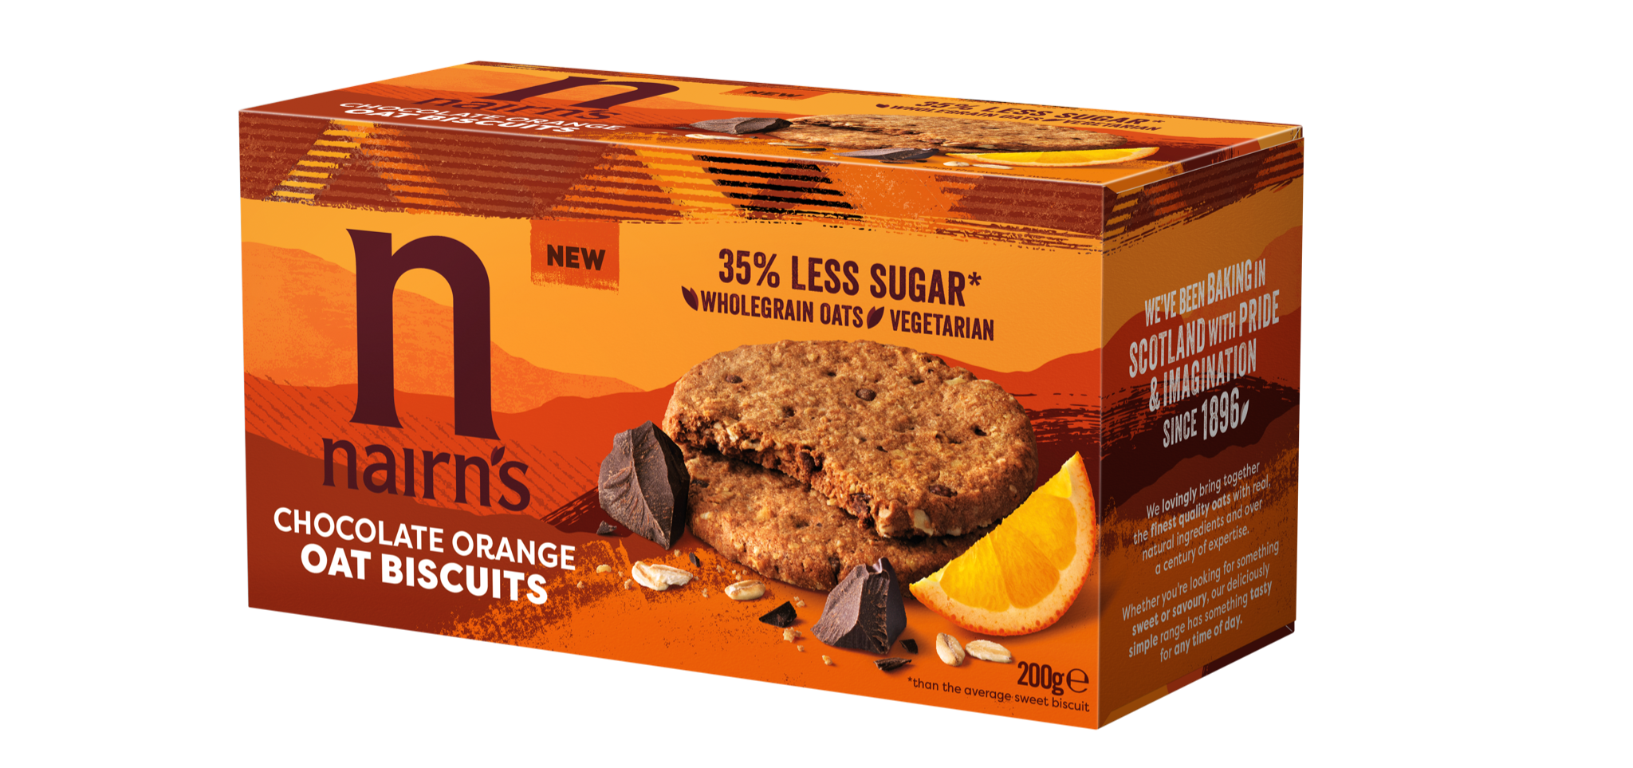
The latest edition to the Nairn’s lower sugar biscuit range!

Building on the success of Nairn’s lower sugar oat biscuits and consumers
appetite for healthier sweet biscuits, Nairn’s have delivered a delicious new oat biscuit to add to their low sugar range: mouth-watering Dark Chocolate & Orange Oat Biscuits, the healthier biscuit choice to grace your biscuit tins!
Naturally energising and low in sugar, these delicious and moreish biscuits are packed full of wholegrain oats, using dark chocolate as a more nutritious option than milk chocolate, ensuring your healthy eating efforts won’t be hindered. With 35% less sugar than the average sweet biscuit, the Nairn’s Dark Chocolate & Orange Oat Biscuits can be enjoyed with your morning coffee or afternoon cup of tea, with absolutely no guilt, and all the pleasure.
Lower in Sugar
According to category reports, Brits spent an extra £160.8m on biscuits in 2020, which amounted to an extra 144 million packets being cracked open - it’s fair to

say that we are still a nation of biscuit lovers, and this isn’t looking to decline at any point soon. With this in mind, a lower sugar alternative is definitely welcome as the government continuously tries to tackle sugar consumption within the UK.
Health benefits at a glance
- 35% less sugar than the average sweet biscuit
- Only ???? calories per biscuit
- Wholegrain oats
- High Fibre
- No artificial colours/flavours/preservatives
- No GM Ingredients
- No hydrogenated fat

Nairn’s Dark Chocolate & Orange Oat Biscuits are available from ????

END

For more information and to see the full range available from Nairn’s please visit
www.nairns-oatcakes.com
For further press information, images or samples, please contact Annabel at CCD PR on 020 7434 4100, or email annabel@ccdpr.com

Notes to editors:
Edinburgh based Nairn’s has been baking with oats since 1896. They are the UK’s number one producer of oatcakes, as well as one of the leaders in branded Gluten Free products with an extensive, growing range that now includes oatcakes, crackers, flatbreads, sweet biscuits, cereals and snacks. Staying true to their roots, all Nairn’s products are deliciously simple, natural and wholesome and do not contain any artificial colourings, flavours or preservatives.
There has been a great deal of research into the positive health and lifestyle benefits of oats. Oats are high in fibre and contain complex carbohydrates that give a natural and wholesome boost. Oats have also been shown to have a beneficial impact on the gut which is widely referred to as the “second brain”.

In 2017, Nairn’s opened the doors of its bigger, ‘state of the art’ gluten-free bakery in Newtongrange, Midlothian, in response to growing demand for Nairn’s Gluten Free products. The new bakery has provided the capacity and technology to expand the range with an ongoing pipeline of new products.

https://www.thegrocer.co.uk/category-reports/essential-items-cakes-and-biscuits-category-report-2020/649442.article

