Embargo 27th April 2026


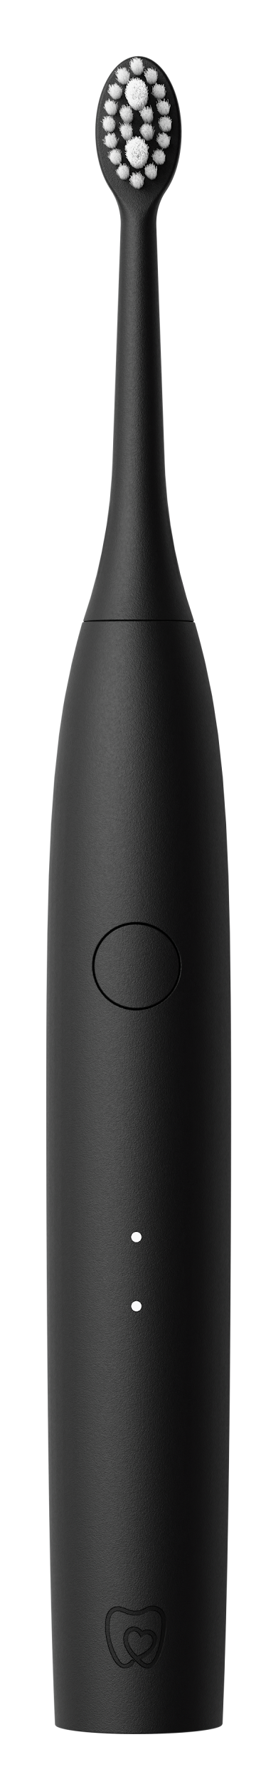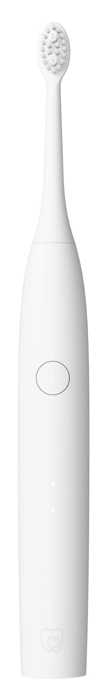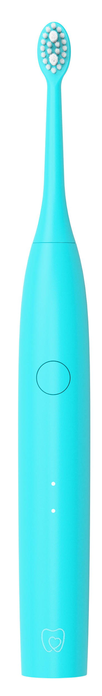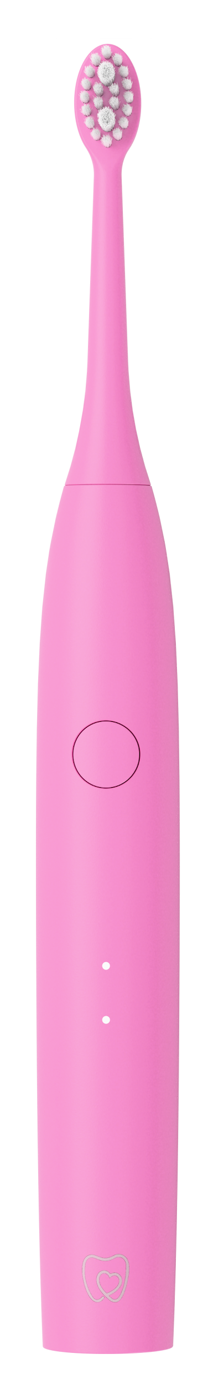

MAKE IT YOURS
Spotlight Oral Care Sonic One Electric Toothbrush

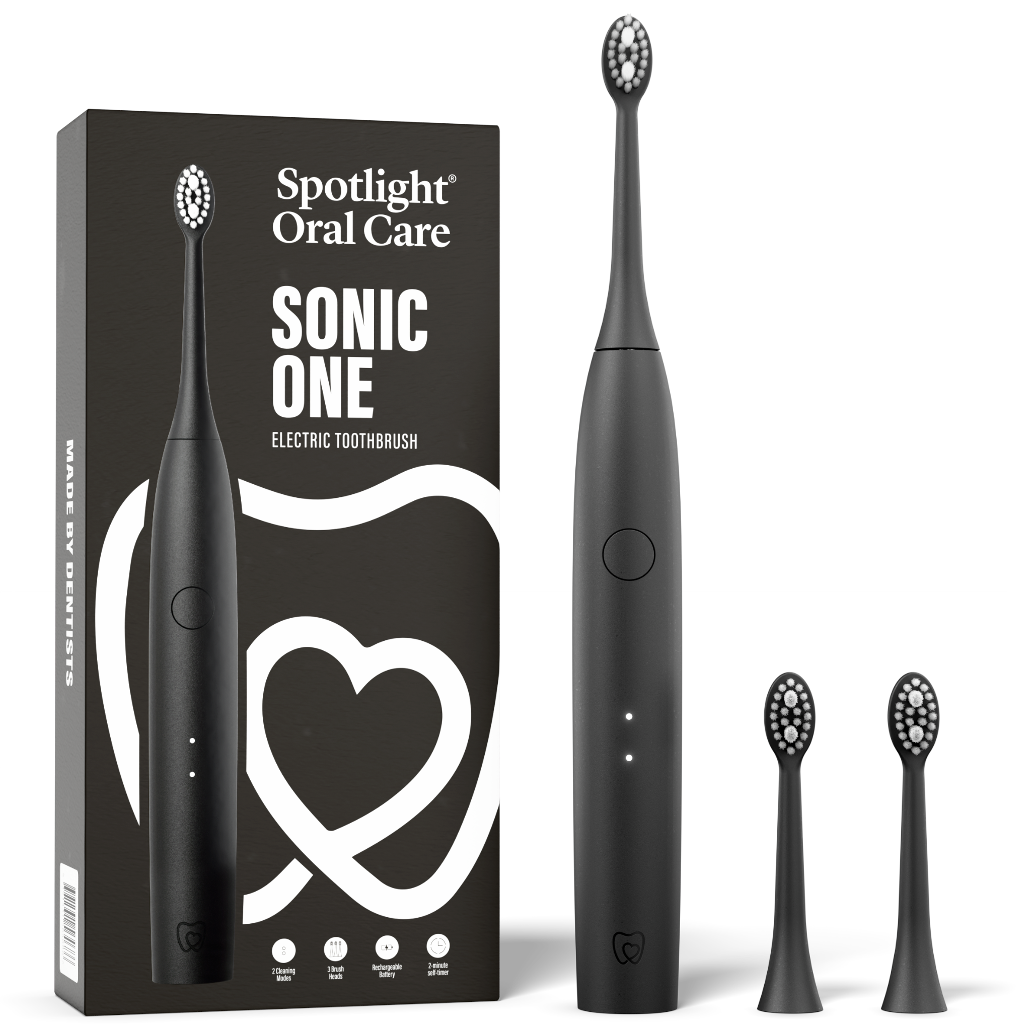
Most Gen Z consumers still use manual toothbrushes, even as electric oral care becomes increasingly mainstream. Many electric toothbrushes are still perceived as too clinical, too expensive, or designed for an older, less design-driven consumer.
Spotlight Oral Care’s Sonic One is designed to change that.
Developed by dentists, Sonic One is a lifestyle-led electric toothbrush created specifically for Gen Z or millennial consumers who want better oral health without giving up style, individuality, or affordability. It reframes brushing from a routine clinical task into a small, everyday self-care moment that fits naturally into modern life.

At a time when personal care is increasingly tied to identity and expression, Sonic One is designed to be seen, not hidden away in a bathroom cabinet. It is available in four contemporary colourways, Pink, Blue, White and Black, making it feel more like a personal accessory than a traditional healthcare device.
Co-Founders & Dentists, Dr Lisa and Dr Vanessa Creaven say, “We wanted to create an electric toothbrush that doesn’t feel clinical or out of reach. Sonic One is about bringing dentist-developed performance into a product that fits how people actually live today, where design, affordability and self-expression matter just as much as function”.

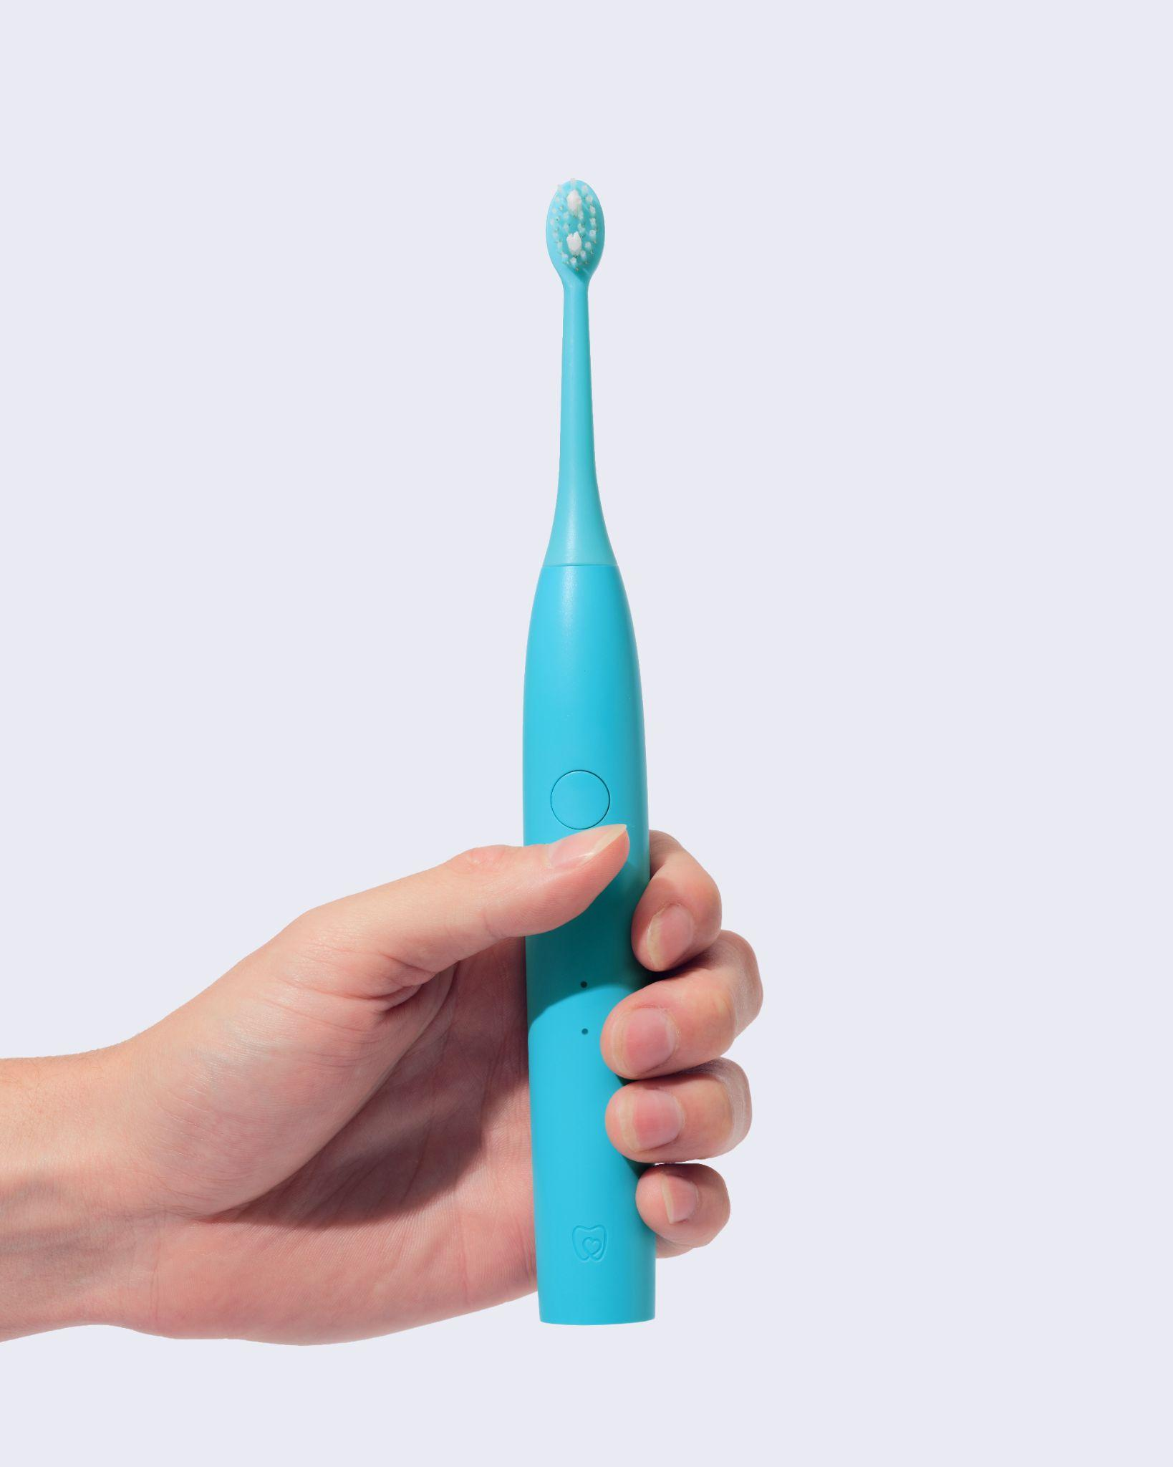
Behind the design-led approach is serious performance. Sonic One delivers dentist-backed sonic technology, reaching up to 40,000 brush strokes per minute for a deep and effective clean that supports improved gum health and everyday oral hygiene. With two cleaning modes, a two-minute timer, 30-day battery life and three replacement heads, It brings clinically developed effectiveness into a format that feels modern, accessible and easy to adopt so you can make it yours. Priced at £44.99, Sonic One is positioned as an attainable upgrade for consumers moving away from manual brushing.
Sonic One reflects a wider shift in how oral care is being redefined. Less clinical device, more lifestyle object. Less obligation, more expression. A simple daily habit, redesigned for a generation that expects even their most basic routines to look and feel better.

Spotlight Oral Care Sonic One Electric Toothbrush RRP £44.95
Available in 4 colours - White, Black, Pink, Blue
Available on uk.SpotlightOralCare.com
ENDS
For further information, samples or imagery, please contact:
Lisa Gannon, Brand Manager, Spotlight Oral Care lisagannon@spotlightoralcare.com
Product imagery
Lifestyle imagery
About Spotlight Oral Care
Founded in 2016 by sisters and dentists Dr. Lisa and Dr. Vanessa Creaven, Spotlight Oral Care’s goal is to create the best clean, clinically proven, effective, and earth-kind oral care products possible, while educating and promoting oral health awareness amongst patients and customers. As dentists, Dr. Lisa and Dr. Vanessa have a unique insight into the needs and concerns of their dental patients, which informs everything they create at the company. Passionate about oral health, and on a mission to make oral care not only effective and clean but sustainable too, Spotlight Oral Care is bridging the gap between oral health and beauty. Whether you’re ready for a whiter, brighter smile or want to say bye, bye to Sensitive Teeth for good, Spotlight Oral Care is on a mission to help the whole family uncover their greatest smile yet.

