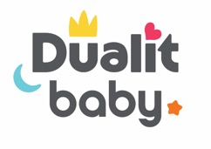
PRESS RELEASE

Announcing the Arrival of Dualit Baby

Iconic British manufacturer, Dualit has used its 75-years of engineering expertise to launch into a brand new electricals category; Baby products. The first products to launch into the Dualit Baby range are its Steam Steriliser and two Baby Bottle Warmers – a Single and a Double variety, all launching exclusively at John Lewis.

Dualit’s Director, Alex Gort-Barten said of this new venture, “Dualit’s focus for the last 75 years has been designing and engineering long-lasting small kitchen appliances and consumables, from toasters to hand mixers, coffee capsules to crockery. We love to innovate and apply our knowledge and expertise to new products, so moving into the Baby market feels a natural progression for the brand. Dualit now caters to every member of the family with reliable household essentials, designed to make life easier – and more enjoyable.”

John Lewis’ Nursery Buyer, Michelle McGuire added, “John Lewis has stocked Dualit’s small electricals since the 1950s as they are consistently dependable and much loved by our customers, so we were keen to be the exclusive stockist for its debut Baby products. I have no doubt that these products will be well received by new parents, and we’re excited to see what’s next in the range.”

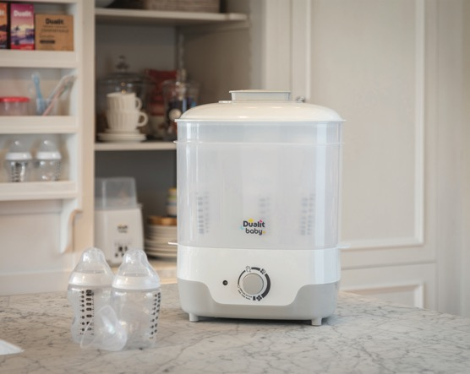

NEW Dualit Steam Steriliser and Dryer - £69

Offering fast results and a generous capacity, the Dualit Baby Steam Steriliser and Dryer features four settings and will sterilise up to six bottles in as little as 15 minutes – just add water! It also benefits from 30- and 60-minute cycles, which will dry the bottles for immediate use. This model features a removable upper rack for accessories such as teats, soothers, lids and breast pump parts and is operated with one simple dial, taking away any stress after a sleepless night. The sterilising cycle kills 99.9% of harmful bacteria without the use of chemicals, with the steam enveloping every surface - even the hard-to-reach areas - for peace of mind. When kept sealed, the items will remain sterile for up to 24 hours.

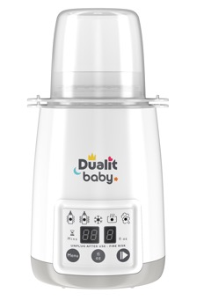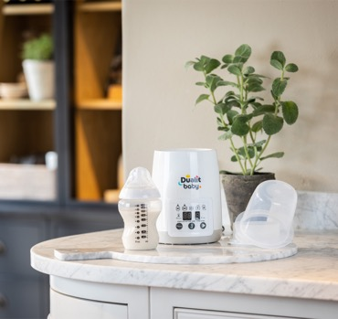

NEW Dualit Single Bottle Warmer - £35

Dualit Baby’s easy to use, multi-functioning Bottle Warmers are designed to sterilise, defrost and warm baby formula, baby food and breast milk. Users can ensure that food or milk is at the optimum temperature for little ones by using the electronic control panel and simply selecting the volume in fluid ounces of the contents. The Bottle Warmer will then calculate how long to defrost or heat to a safe temperature, gently warming to preserve essential nutrients and removing any worry of hot spots. If short on time, a ‘Fast Warm’ function can warm milk 20% faster than the normal cycle, ideal for hungry babies! The handy sterilising function also kills 99.9% of harmful bacteria.

Featuring a contemporary design, the Bottle Warmers are available in Single and Double formations to cater for individual or multiple babies, and are compatible with plastic, silicon and glass as well as single-walled bottles.*

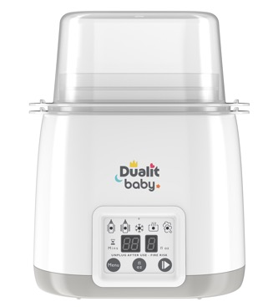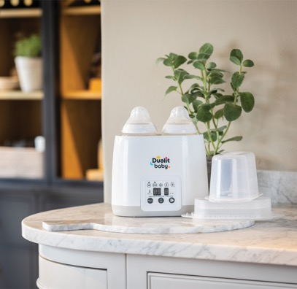

NEW Dualit Double Bottle Warmer - £39

More products will be joining the Dualit Baby range in 2021.

Stockists
Dualit Baby is available exclusively from John Lewis from launch – www.johnlewis.com

ENDS

Notes to Editors

* Dualit Baby Bottle Warmers can fit bottles up to a diameter of 80mm and sterilise bottles up to 105mm tall (without collars, teats and lids); large enough for most sizes, shapes and brands of bottles to fit comfortably.

For more information, high resolution images or samples for review, please contact: Chloe MacDonagh or Francesca Sanchez at Sellers PR on 01962 977 950 or email chloe@sellerspr.com / francescsa@sellerspr.com

