Go 'Smart’ this springtime! Take care of the garden, plan outdoor activities, and prepare for bad weather
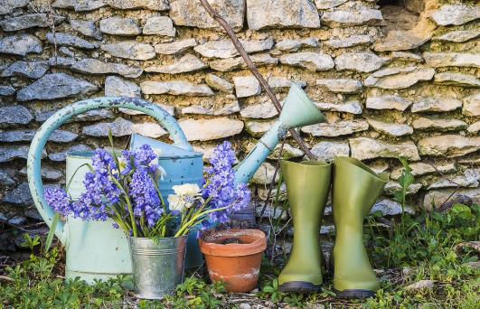
The arrival of spring! There’s no better excuse to get out in the fresh air. Preparing your garden or terrace, resuming outdoor activities, taking out the garden furniture as soon as the weather is good... The Netatmo Smart Home Weather Station can make these springtime tasks easier and help users make the most of this wonderful season.

Taking care of the garden
In spring, most garden, terrace, or balcony owners come out of hibernation. It’s worth taking a few precautions to ensure that the efforts of gardeners are not in vain. With the Netatmo Smart Home Weather Station, users can harness the power of technology to help them. For example, if frost is expected before the return of milder temperatures, users can set an alert when the temperature drops below 3° degrees to remind them to cover their budding seedlings or blooming lilacs. In addition, the Smart Rain Gauge shows the precise amount of rainfall so users can water their plants the right amount without drowning them or wasting water. If there’s enough rain, the ‘smart’ gardener can put away the watering can for another day. If the day’s rainfall wasn’t enough, they can know to water their plants.

Resuming outdoor activities
The return of better weather means people are getting back into outdoor sports. The Netatmo Smart Home Weather Station can help them in their planning for enjoyment and better performance. In addition to having access to real-time weather data on their smartphones, users can also find out the humidity level. This is crucial as a runner’s performance is heavily affected by humidity. When it’s too high, perspiration no longer plays its role properly, meaning the skin and body will struggle to cool down.
Taking a look at the Station’s measurements will help users anticipate the duration and difficulty of the day’s run. To illustrate, a headwind of 50 km/h or more reduces a runner’s performance by 10%. With measurements from the Netatmo Anemometer – an accessory of the Smart Home Weather Station – athletes can adapt their route or postpone their activity depending on the wind’s speed and direction.
Preparing for spring storms
Storms Eunice and Dudley swept across Northern Europe at the end of February, reminding us that wind is still a major part of spring weather. In some storms, the wind can stop people from emerging from their winter cocoon. By setting an alert on their phone, Weather Station and Anemometer users will receive a notification when, for example, the wind exceeds 50 km/h. They can then put the seedlings perched precariously on the windowsill, the chairs dotted around the garden, and the first parasol of the season back in a safe place.

About Netatmo
Netatmo is a leading smart home company that creates simple and smart products for a safer, more comfortable home.
Since its launch in 2011, Netatmo has been committed to designing products that are:
- 100% inclusive: no subscription fees or extra costs
- 100% secure: data protection and privacy guaranteed
- 100% upgradeable: free upgrades and features added regularly
To date, Netatmo has launched 13 smart home devices and accessories. Helpful and easy to use, these products make everyone’s daily life easier while improving well-being at home.
In addition to its consumer product lines, the company collaborates with key leaders of the building industry through its “with Netatmo” program to develop smart solutions that integrate into the home’s infrastructure.
In 2018, Netatmo joined the Legrand Group, a global specialist in electrical and digital building infrastructures.
Netatmo, same home, just smarter.

Press contact
Deborah D’Costa
Zaboura
+44 (0) 203 588 0804
netatmo@zaboura.com

