Introducing boppi's Eco-friendly Toys: Perfect Gifts for Christmas

UK, JULY 2023 – With the festive season approaching faster every year, gift-giving is on everyone's minds, and British brand boppi (owned by Click Europe) has just the right toys to make this Christmas extra special. boppi are introducing its delightful round jigsaw puzzles and the innovative bamboo marble run, both designed to captivate the hearts of children and eco-conscious shoppers alike.

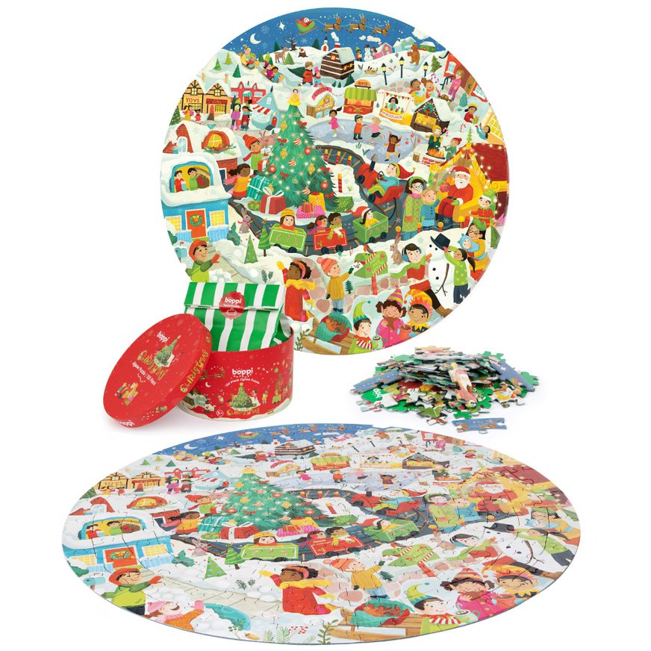
boppi's round jigsaw puzzles are not only a fun and engaging activity for children aged 5 - 8+, but they are also made with environmental sustainability in mind. Crafted from 3 layered, 100% recycled card, these puzzles offer the perfect gift idea for those who prioritise eco-friendly choices. Featuring 7 captivating themes – Space, Dinosaurs, World Map, Seasons, City Life, Animals Around the World, and Christmas – each puzzle showcases adorable, colourful, and whimsical illustrations created by the talented Canadian children's illustrator, Laura Watson.
‘With boppi's round jigsaw puzzles, we wanted to offer children and parents an eco-conscious toy option without compromising on creativity and fun,’ said Steve Finch, Managing Director. ‘The diverse themes and Laura Watson's captivating art make these puzzles a delightful addition to any Christmas gift list.’
The boppi round jigsaw puzzles are priced at £16.99 (RRP) and are conveniently available for purchase on Amazon, www.robertdyas.co.uk, and all good local toy and gift stores.
Another fantastic addition to boppi's toy collection is the boppi bamboo marble run, designed to ignite the imagination of children aged 3 and above. Made with a combination of bamboo fiber, wood, and 100% recycled plastic, this eco-friendly marble run retails at £44.99 and promises hours of creative play. The set comes with interchangeable and connectable parts, allowing children to build multiple structures, enabling marbles to travel from the top of the marble maze to the base through spiral drops, rail tracks, and direction cylinders. The round exit rope collects the marbles as they complete their exciting journey, making tabletop play convenient and enjoyable.
The boppi round puzzle and bamboo marble run offer the perfect combination of creativity, sustainability, and enjoyment this coming Christmas.

- ENDS -

For high-resolution images of boppi's products, please follow the links below:
Puzzles: Hi res product images
Marble Run: Hi res product images
For further information, product samples, or to discuss other exciting boppi toys, including the upcoming launch of our new product line, please contact: Leigh-Ann Hewer, Leigh-ann@carnsight.com, 07514448182

About Click Europe Ltd:
Click Europe is an 18-year-old, family-owned wholesale and retail business, providing toys, video games and leisure products to businesses small and large across the UK. Its toys and products focus on the early years of a child’s development, through to active and imaginative play, across the teenage years and to adult focused fitness and leisure items.
It currently supplies over a thousand product lines, from both its own brands (boppi, bopster, Tiny Trekker, Land Surfer and just be…) alongside well-known brands that have been personally picked by its talented buyers and sales team, such as Playmobil, Half Toys, Candylab, Funko, amongst others.
Today, Click Europe sell to large corporates as well as smaller independent stores, whilst selling its own products through Amazon.
With an overall goal to provide quality, fun and where possible sustainable products to businesses and customers across the UK and Europe.
Click Europe stand for Timeless, Family, Fun.
Website: https://clickeurope.com/
LinkedIn: https://www.linkedin.com/company/click-europe-ltd/?originalSubdomain=uk
Facebook: https://www.facebook.com/clickeuropelimited/

