KEEP LUNCHES FRESH AND TASTY WITH THE NEW
FRESH & SAVE SOLUTION FROM ZWILLING

ZWILLING has a long history of championing perfect food preparation and culinary innovation, almost 300 years in fact, and with food waste at an all-time global high, this German company has taken the lead by launching a new FRESH & SAVE vacuum sealing system. Not only will this new collection of kitchen products help to reduce food waste by keeping food fresh for up to five times longer but it will also preserve food’s flavours and vitamins, locking goodness in.

As well as preserving and storing fresh produce, leftovers and pre-prepared meals, FRESH & SAVE is also ideal for keeping lunches fresh and tasty. With Vacuum Boxes in Glass, Plastic and Lunchbox designs as well as handy Vacuum Bags, this new food preserving solution has everything you need for lunches at home or on the go. Thanks to the FRESH & SAVE Vacuum Pump, you can seal in flavour and goodness, keeping your lunch, soup or snack fresher for longer. This has the added benefit of reducing food waste as well as making life easier and more convenient, saving time and money at the same time.
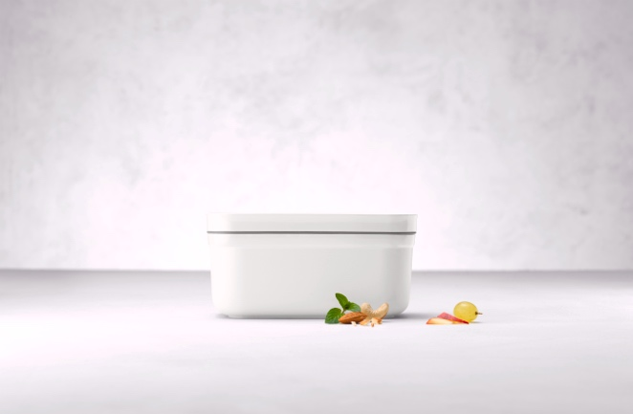

ZWILLING FRESH & SAVE Vacuum Plastic Lunchbox, £9.95
The benefits of vacuum-packed food are many. When we store ingredients, meals or leftovers in the fridge, the quality, flavour and freshness decline rapidly and often lead to food waste. In fact, the average food waste per household is 75kg per person per year*. This is because the food comes into contact with air and when food is frozen, this leads to freezer burn, which again reduces flavour and goodness. To prevent meat, fish, cheese, salads, herbs, spices and more from drying out, becoming mouldy, tasteless or limp, a vacuum seal will keep it all fresh for longer. It preserves taste, keeps cooked and raw produce fresh and saves money!
The new FRESH & SAVE collection from ZWILLING comprises four food preservation products that are designed specifically to keep ingredients and meals fresh for longer, reduce food waste and make life simpler at the same time. The Vacuum Pump, Vacuum Boxes, Vacuum Bags and Vacuum Wine Sealer all offer the perfect solution to food waste and sustainability. Each product offers functional, timeless design with ZWILLING’s Double Sealing Technology and a 24-month guarantee.
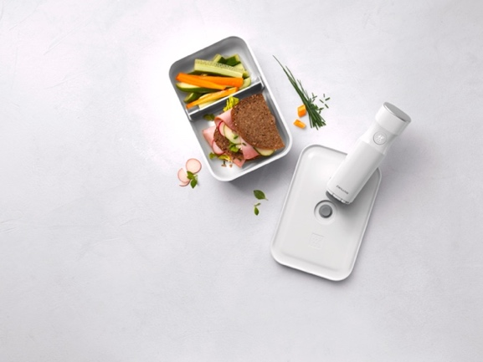
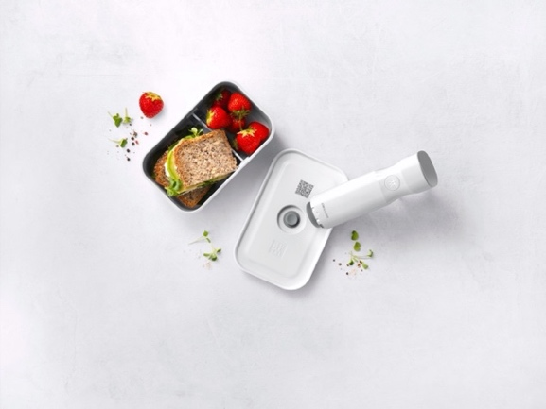

Left: ZWILLING FRESH & SAVE Vacuum Plastic Medium Lunchbox, £13.95
Right: ZWILLING FRESH & SAVE Vacuum Plastic Large Lunchbox, £17.95 both with
ZWILLING FRESH & SAVE Vacuum Pump, £69.95

Start your collection with the FRESH & SAVE Vacuum Boxes, which come in small, medium and large sizes in glass or plastic along with plastic compartmentalised medium and large lunchboxes, a gratin dish and a flatter box perfect for meats and deli items. The plastic medium and large Vacuum Lunchboxes are great for dividing sweet and savoury items, keeping sandwiches separate from juicy fruits or succulent salads and popping some pasta onto the side of a bagel or baguette. The FRESH & SAVE collection works by sealing the lids or bags with the Vacuum Pump, locking flavour, freshness and goodness in. The boxes can also be used without the vacuum element as a standard lunchbox and they are dishwasher and microwave-proof {with vacuum seal released}. The glass boxes are also oven-ready too with the lid removed up to 180°C.
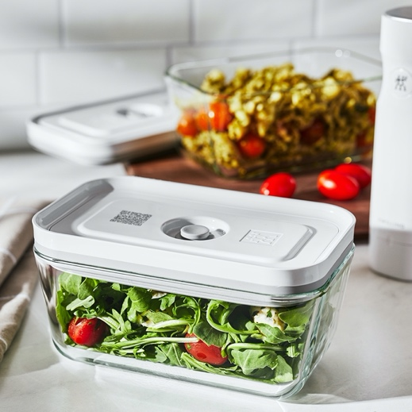

ZWILLING FRESH & SAVE Medium Glass Vacuum Box, £14.95
To seal in freshness, you’ll need the wireless FRESH & SAVE Vacuum Pump, which is always ready to go as it doesn’t require complicated setting up and simply starts at the touch of a button then automatically stops once the correct vacuum is achieved. It only takes a few seconds to complete the vacuum process and it can be recharged using the USB cable included. It’s whisper-quiet, easy to use and ultra-convenient - perfect for keeping a wholesome, tasty lunch or snack bursting with freshness.
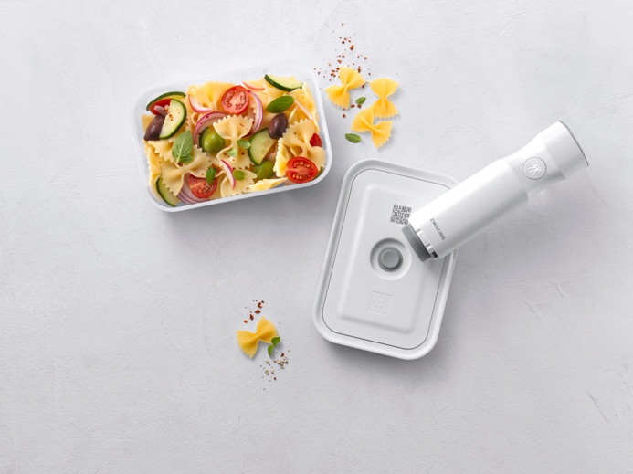

ZWILLING FRESH & SAVE Medium Plastic Vacuum Box, £14.95 with Vacuum Pump, £69.95
Highly versatile, ZWILLING’s FRESH & SAVE BPA-free Vacuum Bags can be used in the fridge and freezer, are microwave safe and can also be used to prepare sous vide dishes thanks to a heat resistance of 100°C. Available in a variety of sizes, the bags are easily cleaned by hand to ensure a reusable design.
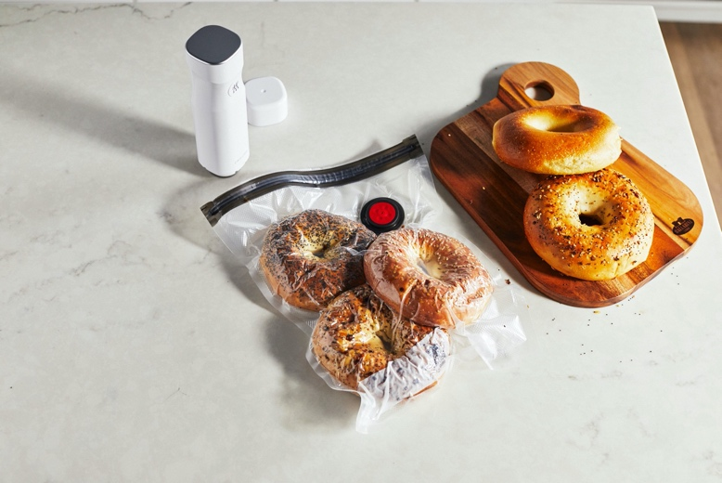

ZWILLING FRESH & SAVE Vacuum Bags, from £5.95 for X3 Large with Vacuum Pump, £69.95
The other great thing about the new FRESH & SAVE collection from ZWILLING is that all the Vacuum Boxes and Bags come with a QR code, which can be used with the ZWILLING Culinary World app to scan the contents. The app then tells the user when the contents are approaching their extended shelf life date, reducing food waste as well as saving money. There’s also a handy label for those who prefer the ‘old school’ method of simply writing the contents on.

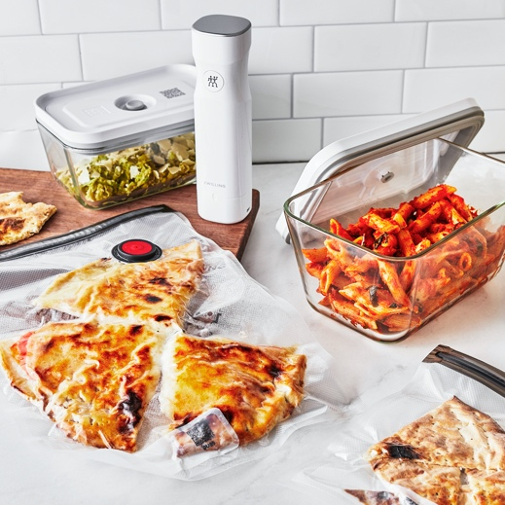

ZWILLING FRESH & SAVE Vacuum Bags, from £5.95 for X3 Large with Vacuum Pump, £69.95
and Vacuum Boxes in Glass, £39.95 for X3 including Small, Medium and Large
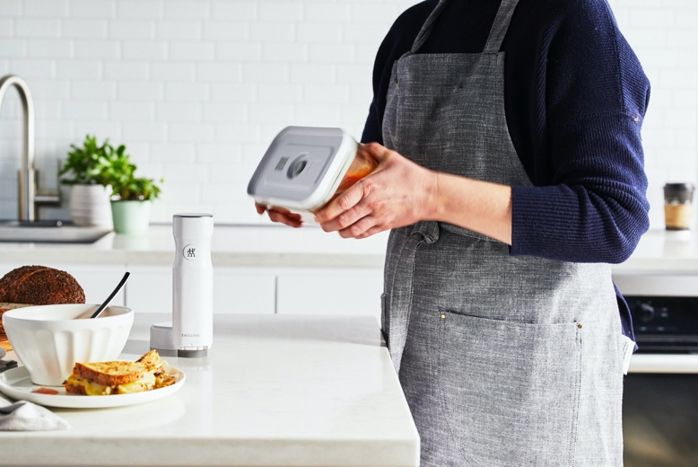

ZWILLING FRESH & SAVE Medium Glass Vacuum Box, £14.95 with Vacuum Pump, £69.95

ENDS
ZWILLING FRESH & SAVE is available from https://uk.zwilling-shop.com #freshnessextended!

For more information, high res imagery or product loans for testing and photoshoots, please contact francesca@sellerspr.com | katherine@sellerspr.com or call 01962 977950

*Thomas Schmidt, Felicitas Schneider, Dominik Leverenz, Gerold Hafner Lebensmittelabfälle in Deutschland (Food Waste in Germany) – Baseline 2015 – Summary Thünen Report 71 Braunschweig, Germany, September 2019

