**SHARING IS CARING: BEST SHARING COCKTAIL RECIPES**

*Put the phones away at your next gathering with friends and family and enjoy some delicious sharing cocktails*

In a world where we’re constantly glued to our phones, it’s always good to take a moment to unwind and spend quality time with friends and family. Now that the weather’s improving and the sun is starting to come out of hiding, what better way to host your favourite people than with some delicious, easy-to-make sharing cocktails?

Drinks expert and leading ice manufacturer, The Ice Co, has launched its *Break the Dev(ice)* campaign – encouraging people to get together in-person, over a cold drink, to have more meaningful conversations. The survey carried out as part of the campaign has shown that as a nation, we veer towards announcing important, personal news via text, as opposed to a phone call or, better yet, in-person; one in six said they would tell friends and family about getting engaged via text, and a further 11% said they would even text to announce a pregnancy.

While so many people opt for communicating with friends and family over text, the wellbeing benefits of catching up in-person are clear – 50% of us say it makes us feel happier and a further 28% say it helps us to feel less stressed.

With this in mind, The Ice Co is encouraging Brits to come together to have more meaningful conversations over an icy, refreshing drink – which ranked top for our preferred way to meet family and friends.

Here’s its top cocktail recipes that are perfect for your next catch-up and can be batch-made so you can concentrate on spending that quality time with your friends and family.

For more recipes, head over to the website: [www.theiceco.co.uk](http://www.theiceco.co.uk)

**Blue Lagoon Fish Bowl**

**Ingredients:**

* 250ml vodka
* 250ml blue curacao
* 1l lemonade
* 1 bag of [Party Ice](https://www.theiceco.co.uk/our-products/party-ice/)
* Garnish: maraschino cherries and orange wedges

**Method:**

1. Add the vodka and blue curacao to your jug or fishbowl and stir, then fill generously with Party Ice. Add the lemonade and stir to combine.
2. Garnish your jug with orange wedges and maraschino cherries.
3. To serve fill your glass with Party Ice and pour the cocktail over the top, adding an extra cherry and orange wedge on top for garnish.

**Raspberry Mojito Fish Bowl**

**Ingredients:**

* 450g raspberries
* The juice of 4 limes
* Mint simple syrup
  + x 1 cup sugar
  + x 2 cup water
  + x 1 cup fresh mint leaves
* 300ml white rum
* 1l of soda water
* [Polar Cube](https://www.theiceco.co.uk/our-products/polar-cube/) ice
* [Crushed Ice](https://www.theiceco.co.uk/our-products/crushed-ice/)
* Garnish: mint sprigs, raspberries and lime wedges

**Method:**

*For the mint simple syrup*

* 1. Over a medium high heat, bring the sugar and water to a low boil in a saucepan.
  2. Stir until the sugar dissolves and then simmer for a few more minutes without stirring, when the mixture has reduced to half the amount you started with this is ready.
  3. Add the mint leaves to a bowl and pour the syrup over them and cover until cooled, sitting for around an hour until you can strain it ready to use.

*For the mojitos*

* 1. Muddle the raspberries in the bottom of your pitcher or fishbowl, along with your simple mint syrup. Add the rum and lime juice then stir until combined. Add to the fridge to chill for at least 1 hour.
  2. When ready to serve add Polar Cube ice and soda water and stir gently.
  3. Pour into glasses filled with crushed ice and garnish with a sprig of mint, a lime wedge and raspberries to serve.

**Watermelon Cooler**

**Ingredients:**

* x4 handfuls [Party Ice](https://www.theiceco.co.uk/our-products/party-ice/)
* x1 whole watermelon
* x2 lime
* x1 bottle lemonade or sparkling water

**Method:**

1. Remove the skin and pips of a watermelon, cut into chunks and add to a blender. Save some slices of watermelon for later!

2. Add two handfuls of Party Ice and the juice of one lime. Blend for 30 seconds or until mixed.

3. Pour into a drinks dispenser over two handfuls of ice and top with lemonade or sparkling water. Add slices of lime and watermelon for decoration. It's now ready to serve!

**Pink Gin Iced Tea**

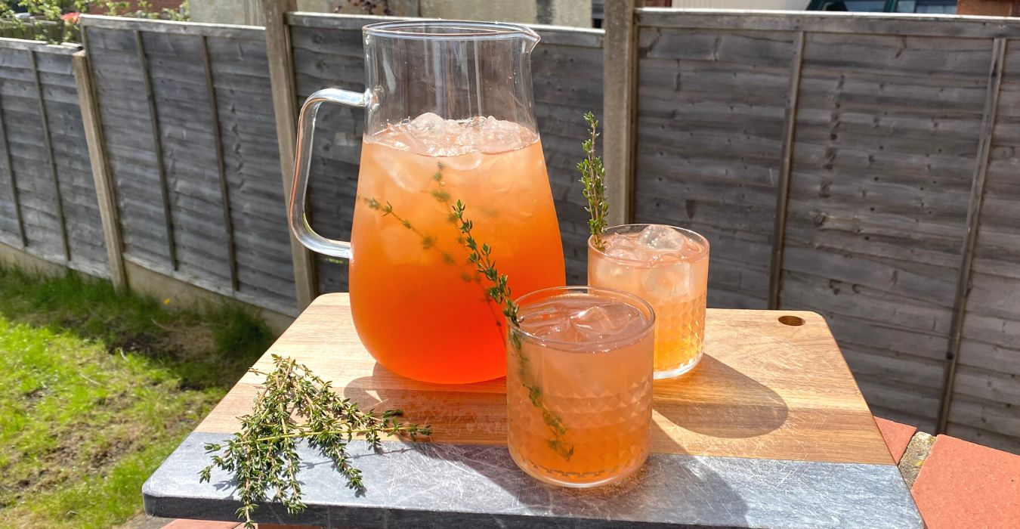

**Ingredients:**

* x1 bag of [Polar Cube](https://theiceco.co.uk/our-products/polar-cube/) ice
* x1 chamomile tea bag
* x100ml pink gin
* x100ml spiced rum
* x100ml elderflower cordial
* x100ml pink grapefruit juice
* Garnish: sprigs of thyme

**Method:**

1. Brew the chamomile tea bag with 500ml boiling water for a few minutes before removing the teabag and leaving to cool.
2. Fill your jug with Polar Cube ice, saving a few cubes for each glass.
3. Add the pink gin, rum, elderflower cordial, grapefruit juice and cooled tea to the jug and stir.
4. Add in a few sprigs of thyme and stir again.
5. Fill glasses with the leftover Polar Cube ice and add the iced tea. Garnish with a sprig of thyme to serve – enjoy!

**ENDS**

**Contact**

For all media enquires please contact the The Ice Co. press team on [theiceco@hatchpr.co.uk](mailto:theiceco@hatchpr.co.uk) or 0113 361 3600.

**Notes to Editors**

Survey conducted in April 2023 by TLF Panel, involving 2,004 respondents across the UK.

**About The Ice Co**

Established in 1860, The Ice Co is Europe’s leading ice manufacturer. The business produces its own ice from its UK factories and supplies retail, wholesale, foodservice, events, and food manufacturing, both in the UK and abroad. It has also won a string of awards, such as The Grocer’s SME of The Year Award 2020 and has held the title Frozen Food Manufacturer of the Year for two years running.

The Ice Co’s key product lines include Party Ice, Crushed Ice, Polar Cubes, and Super Cubes - the super-sized slow melting ice cubes, made from spring water. For more information, please visit [www.theiceco.co.uk](http://www.theiceco.co.uk/).