As a brand which celebrates parenthood and all things surrounding the essence of a family bond, there's no better gift this Father’s Day than a hand-engraved keepsake, personalised for him.

We also have a new Unisex range launching June 4th. All pieces are made with 925 sterling silver, 18k Gold Plating & Beads including Matt Black Agate, Tigers Eye and Labradorite, which are completely new to this collection. All pieces are complimentary hand-engraved and shipped within 24 hours.

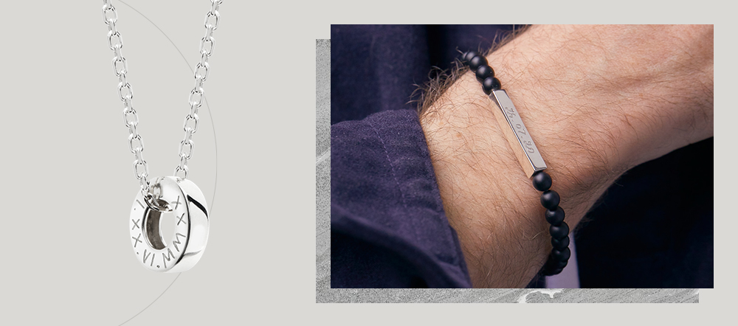
(L-R: New Unity Necklace at £79 and Bar Beaded Bracelet at £69)

All prices and names are linked below.

https://drive.google.com/drive/folders/1RPz-qHUylBLZcgB-obVHQyFQGFT2Vs3J

